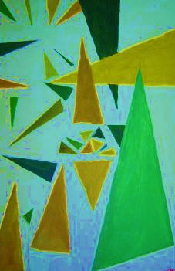
Jr. High Art Elective Winter – Spring 2017

- Shape Compositions
Geometric Shapes
Tempera Paint
Colour Schemes
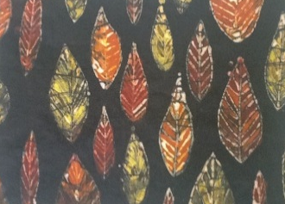
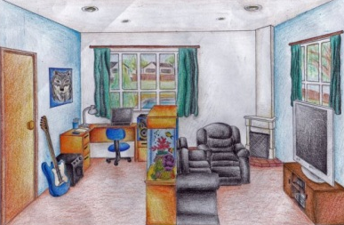
- Batik (Wax and dye to create designs)
Organic Shapes

- Perspective Drawing
Room design in one-point perspective
Surprise elements
- Stencil Relief Collage
Human figure in movement

Additional possibility – instrument painting!

