Art 10
NOTES
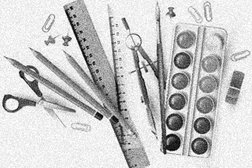

Name _______________________________

ART 10 COURSE OUTLINE AND INFORMATION SEMESTER 1 2018-19

Art 10 is a foundational course, covering a wide variety of concepts, skills, media and techniques; it is also designed to stretch your imagination and creativity. Art 10 may be taken as either a 5-credit or a 3-credit course: if as a 3-credit, a little more than half of the following will be covered.

Unit I Developing Composing and Drawing Skills

A. Arranging for Unity in Composition
~ still life drawing
~ elements and principles of design

B. Drawing Methods
~ contour, gesture, contour-gesture, modelled drawings

C. Linear Perspective
~ principles of perspective
~ one, two, and three-point perspective

D. Drawing in Various Media
~ pen and ink
~ oil and chalk pastels
~ charcoal pencil
~ wax crayon
~ conte
~ collage elements
~ uses and effects

E. Critiques (in every unit)
~ describing and discussing work from compositional viewpoint

Unit II Exploring New Directions

A. Positive-Negative Space
~ three concepts

B. Art and Social Concerns
~ social comment

C. Abstraction
~ four methods (simplification, distortion, exaggeration, rearrangement)
~ poster/self-portrait in choice of media from Unit I

D. Critiques

Unit III Creating Movement in Art

A. Movement in 3D
~ a look at 20th century sculpture
~ wire and papier-mache figures

B. Watercolour Studies/Painting
~ colour theory
~ painting techniques
UNIT IV

A. Ceramics
~ emphasis on surface and texture
~ handbuilt pottery

B. Printmaking
~ emphasis on creating decorative abstract images from natural forms
~ monotype and blockprinting (lino-cuts)

General Information

Sketchbooks (SB)/Visual Journals
Please have your SB with you in class at all times, but also take it home in order to complete your sketchbook assignments.
REQUIREMENTS: 5-credit students – 20 drawings; 3-credit students – 14 drawings. At least half your drawings should include elements from life (they may be combined with imaginative elements). Choose your own assignments from the list provided (it will also be posted in the classroom and on Weebly). Please include with each drawing: the # of the assignment, your signature, and the date you completed the drawing.
I will be marking your sketchbook/journal only twice, one at the end of each quarter. It is worth 20% of your term mark. I will not formally check your assignments but I will be looking in your sketchbooks informally on a regular basis.
You will also use your sketchbook for information, thumbnail sketches, and various studies in preparation for larger pieces.

Notebooks
You will be given all handouts and paper you need in a folder at the beginning of the course. Please leave it in the classroom at all times except when you are studying for a test/quiz.

Portfolios
All class (studio) work should be kept in your portfolio. Please be in the habit of putting all your work away every day.

Quizzes
Instead of major tests, you will have a series of short quizzes throughout the semester. These will be given after each section of theory. Please have your notebook in class every day in order to be prepared to take notes and to review your notes.

Evaluation
Quarter Grade: Quizzes 15% Final Grade: Quarters 80%
Final Exam 20%
Sketchbook 20% 100%
Studio 65%
100%

Art History A Survey of Western Art 3

Series I Series II
Paleolithic/Neolithic Approximately Baroque 1600 AD (CE)
Egyptian 30,000 BC (BCE) Neoclassicism
Greek Romanticism
Roman Realism
Early Christian Impressionism
Romanesque Post-Impressionism
Gothic Expressionism, Abstraction, Fantasy
Early Renaissance Surrealism, Pop, Op 19603s AD (CE)
High Renaissance 1559 AD (CE)

Absence Policy: If you miss a class, you must make up the time after school (40 minutes over 2 days). Exceptions to this rule are absences due to doctor’s appointments, illness, funerals, and special family occasions such as weddings and graduations, provided you are COMPLETELY CAUGHT UP WITH YOUR CLASS WORK AND HOMEWORK.

Summative Assignments
The following is a list of assignments (subject to change!) that will be given summative marks and therefore must be completed in order for you to receive a mark in the course. All summative studio (#1-10) assignments must include a REFLECTION on the process (ie. you must write a short paragraph about your experience creating each piece – challenges, successes, what you might do differently next time, things that worked well, what you enjoyed/didn’t enjoy about it, etc.) Summative assignments will be marked according to the assessment rubric posted in class. Total marks for each assignment will vary. (3-credit students will do slightly more than half of the following.)

- Figure drawings
- Contour and modeled drawings
- Media themes
- Poster based on theme
- (Caricature)
- Self-portrait Abstraction
- 3D papier-mache figure
- Watercolour painting(s)
- Ceramic piece
- Block print/lino print
- Sketchbook assignments
- All tests/Art History assignments

ART 10/20/30 COMPOSITION/ELEMENTS/PRINCIPLES in ART

I What is composition?
The organization and arrangement of the visual elements (ie. line, shape, value/tone, colour,
texture) in a work of art in a unified way. All 2D art can be analyzed by these standards,
whether representational or non-objective, or anything in between.

II Elements – ie. tools or ingredients of art

1. LINE- expressive of mood; leads eye through comp.; creates movement, creates structure, pattern, texture, shape, tone.

2. SHAPE – all objects can be reduced to simple shapes, whether geometric or organic. Shape can be distinguished by all other elements.

3. TEXTURE – visual or tactile (seen or felt); create with all other elements.

4. TONE/VALUE – lightness and darkness – helps create mood, focus, pattern, rhythm,
form (modeling).

5. COLOUR – mood, symbol, light, movement, creates form.

III “Preliminaries” or Foundational principles of 2D art

1. PICTURE PLANE – FLAT surface artist works on; may be treated anywhere from 2D (usually
decorative) to 3D (illusionistic, like a window), and anywhere in between.

Picture Plane is
2D, ie. unbroken. Picture Plane is 3D, ie. broken.

2. FRAME SHAPE – boundaries of picture plane; shd fit comp; rectangle most common.

3. POSITIVE AND NEGATIVE SHAPE – positive is what is first laid down by artist; negative is“leftover”;
can be clearly pos or neg; can flip-flop; can be ambiguous.
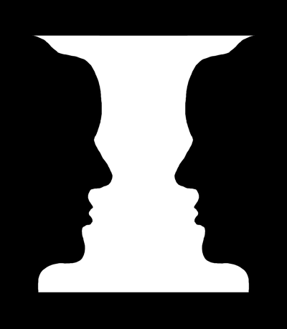
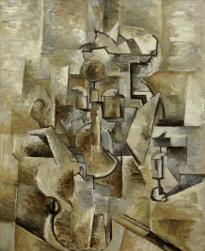
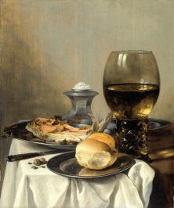

4. PERSPECTIVE – showing (illusion of) depth on flat surface by various methods.

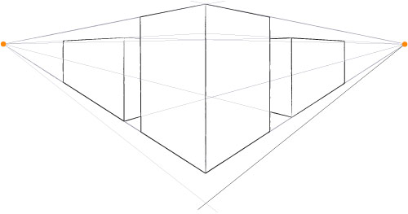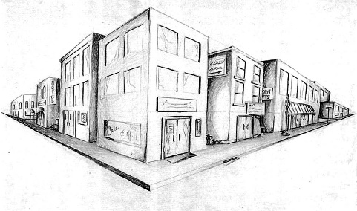

IV Principles – guidelines for using tools
- FOCAL POINT – starting pt./resting pt. from which all eye movement begins.
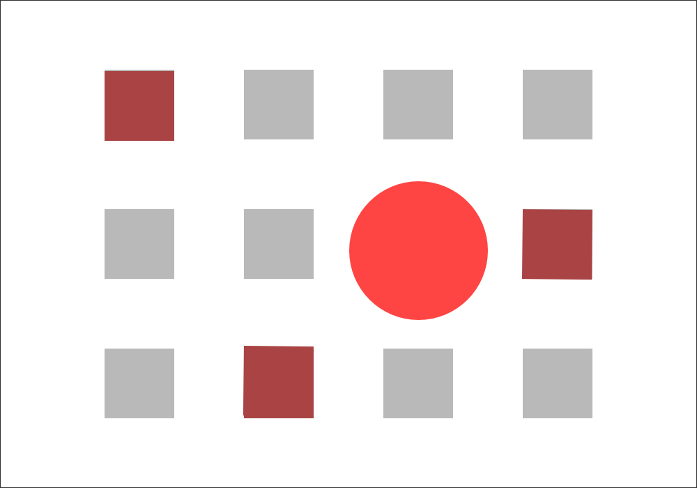

2. Movement – the visual movement directed by the artist to bind the parts “…should
assure that all areas of the picture plane are exploited, ie. that there
are no DEAD SPOTS…by directing shapes and lines toward each other…
so that the spectator is unconsciously swept along visual channels”.
(Art Fundamentals, p.34)
What hinders movement? 1) object(s) in middle of picture plane
2) repeating frame shape within plane
3) empty space at edges – if you can cut off edges without affecting the
comp., movement not working.

3. SAMENESS/REPETITION – repeating elements (whether shapes, colours, lines, etc.); not always
exact duplication, but similar. Rhythm through repeated elements helps create movement.
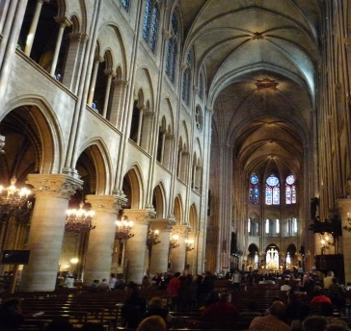
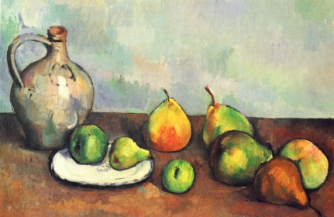

4. VARIETY – opposite of harmony; contrast, differences to add interest. Eg. varying heights of objects
(simple triangular comp, 3 objects, 3 heights, usually works well)
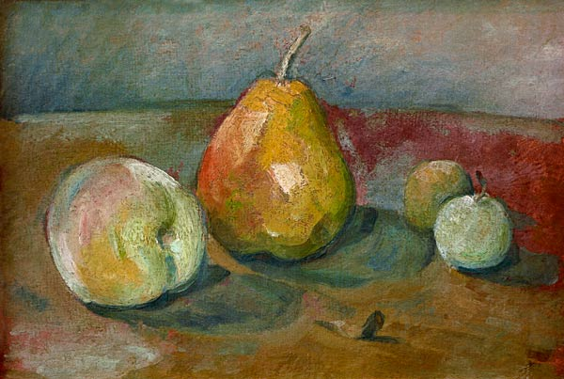

5. BALANCE – visual equality (in attention) on both sides.
a. symmetrical – same arrangement of elements on both sides.
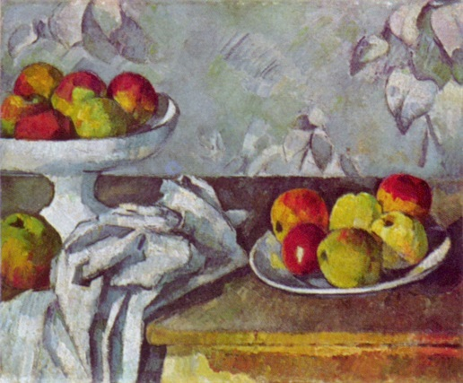
b. asymmetrical – different arrangement. More interesting. Hint: use odd number of objects.
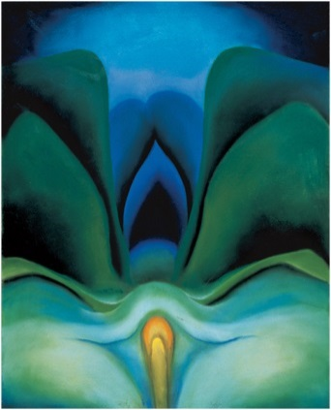
.

6. UNITY – total effect of all parts working together; “comfortable” compositions have unity.

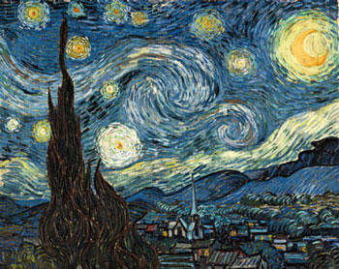

ART 10 DRAWING METHODS (See your sketchbook/journal for examples)

- GESTURE: A quick, spontaneous method focusing on the “inner energy” of the form rather than the edges. Keep drawing tool on surface until drawing complete.

- CONTOUR: Drawing only the edges/outlines of the subject; a slow, deliberate method; aim for a smooth, confident line as opposed to a broken “scrubbed” line.

- Blind Contour: Drawing subject looking ONLY at the subject, not at your paper.
- Modified Contour: Drawing subject looking MOSTLY at the subject, a bit at your paper.
*SIGHTING: A technique used to improve proportion; using your finger or pencil to measure sections of your subject in comparison to other sections.

- CONTOUR-GESTURE: A free, energetic drawing which touches the edges. Best not to remove drawing tool from surface until drawing complete.

- MODELLED/MASS: A drawing which is shaded (ie., using a variety of tones) to give a sense of solidity, mass, weight. Tonal changes are influenced by light and texture.

Some modeling methods and suggested media:
- Smudging – charcoal, conté
- “Shading” – pencil, conté, coloured pencil
- Hatching/Cross-hatching – pen and ink, pencil, marker, ballpoint pen
- Stippling – pen and ink, marker, ballpoint pen

ART 10,20,30 ABSTRACTION METHODS (See Presentation on Weebly for examples)
What is Abstraction?
Abstraction comes from the verb “to abstract”, which means “to take away from”. True abstract art, then, always begins with something from real life which the artist changes in some way. There are four main ways artists abstract things from real life.

- SIMPLIFICATION: Taking away details, flattening 3D objects into organic or geometric shapes; flattening colours

- DISTORTION: Making specific parts bigger, longer, smaller; twisting or “melting”; drastically changing texture or colour.

- EXAGGERATION: Magnifying or multiplying object; making object significantly smaller.

- REARRANGEMENT: Taking object apart and reassembling it in a new way; showing more than one point of view at a time.

What is Nonobjective Art?
Art which has as its source something NOT from real life is called “Nonobjective”, literally “no object”. Nonobjective art focuses instead on the elements inherent in art, ie. line, shape, colour, tone, texture, space.

ART 10 PERSPECTIVE (Methods of showing depth on a 2D surface)

Principles of Perspective
- Objects up close are larger than objects of the same size farther away.

- Objects up close are lower on the paper; objects farther away are higher on the paper.

- Objects up close overlap objects that are behind them.

- Objects up close usually appear darker and more vivid than objects in the distance which are lighter and hazier. This is called ATMOSPHERIC PERSPECTIVE.

- Parallel lines converge (come together) at the horizon line. This is called LINEAR PERSPECTIVE. There are 3 methods used to create linear perspective.

One-Point = one vanishing point (*NB. All corners of cube are vertical.)

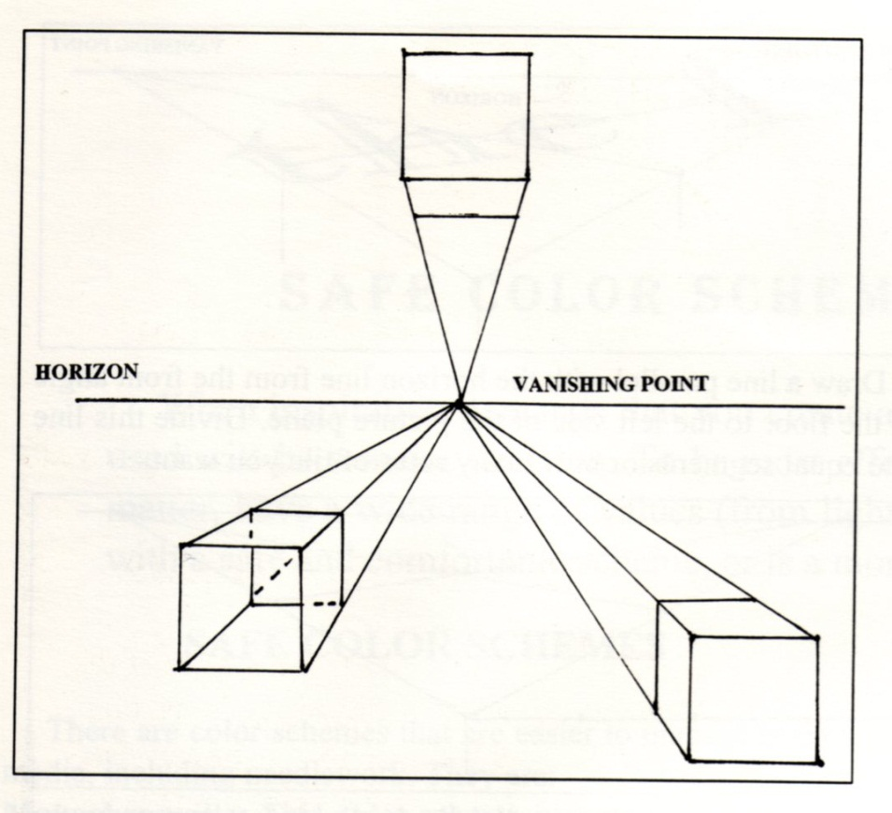

- Two-Point Perspective = two vanishing points (*NB. All corners are vertical and all sides converge at horizon line.)
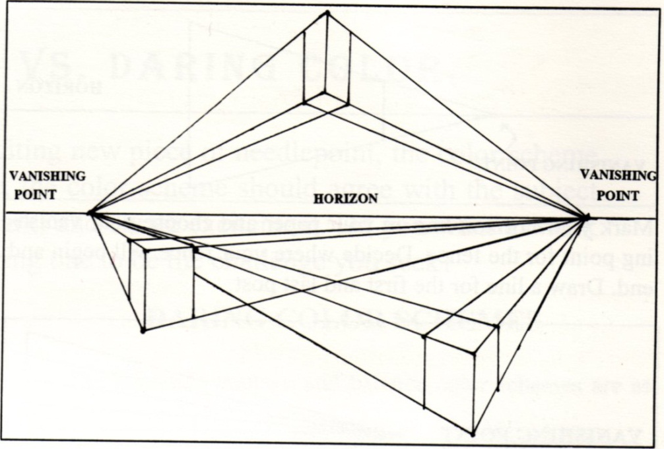

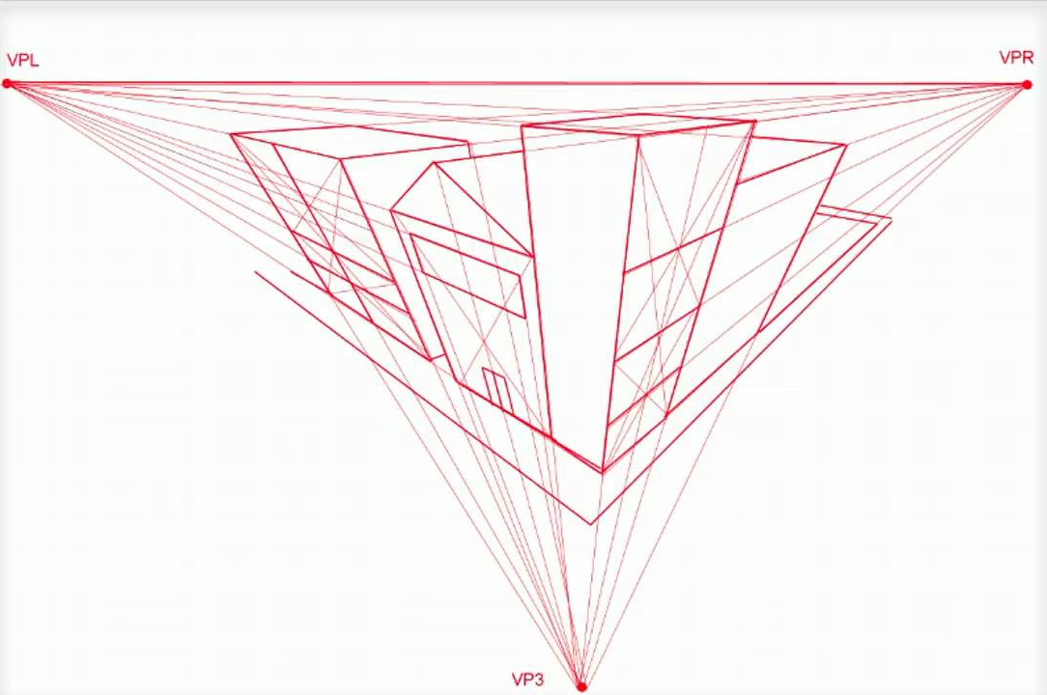

- Three-Point Perspective = three vanishing points (*NB. May be one or no vertical corners and all sides converge in three directions.)

ART 10 POSITIVE-NEGATIVE SPACE

What is POSITIVE (in a 2D work of art)? Whatever is initially drawn. Positive and sometimes referred to as “figure”.
What is NEGATIVE? The area left over after the initial thing drawn. Negative is sometimes referred to as “ground”.

There are three ways to approach the relationship between positive and negative.

- Positive and negative are clearly defined; figure is positive and ground is negative. In the illustration the apple is positive and the space around it is negative.
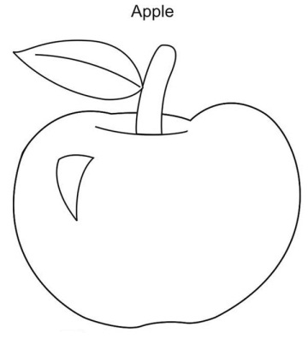

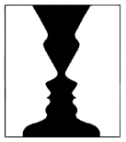
- Figure-ground can be either positive or negative, ie., they can “flip-flop” and be looked at either way. In the illustration the white can be seen as “figure” on a black “ground”, or the black can seen as “figure” on a white “ground”.

- Positive and negative are difficult to tell apart; they are ambiguous or can appear to melt into each other. In the illustration it is hard to tell where the buildings, the “figure”, begin and end.
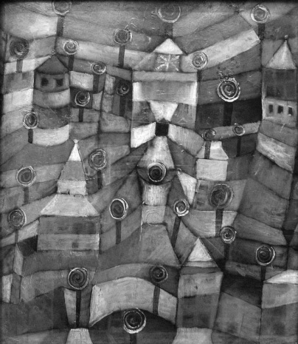

ART 10,20,30 PORTRAIT PROPORTIONS (The proportions of the human face)
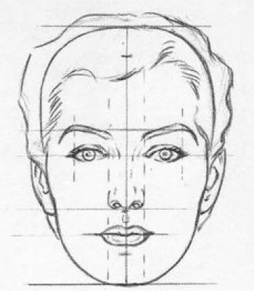

THINGS TO REMEMBER!!
- Midpoint of eyes is halfway between top of head and bottom of chin.
- Bottom of nose is halfway between midpoint of eyes and bottom of chin.
- Width of nose = space between eyes.
- Ears generally lie between midpoint of eyes and bottom of nose.
- Neck is drawn from jawline gradually widening toward shoulders (not in drawing).

ART 10 CARICATURE

What is Caricature?
A caricature is a drawing intended to ridicule something or someone, usually in order to create satire or make a political comment. A portrait caricature is a distorted or otherwise abstracted representation of a particular person, intended to be humorous.

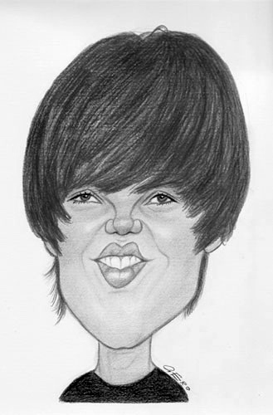
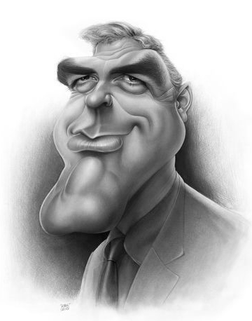

What facial characteristics are being emphasized (through distortion) in each of these people?

ART 10 SCULPTURE/3D ART
What is sculpture/3D art?
The art of expressively shaping 3D forms. 3D art has an increased sense of reality because it occupies space just like humans do. It is important to make a 3D piece interesting from ALL sides.

There are four basic sculptural methods:

- ADDITION: To build up, construct, assemble.
Possible materials: wood, found objects (objet trouvé), metal, etc., put together with nails or glue, or welded together.

- SUBTRACTION: To cut away, carve.
Possible materials: marble, wood, soap, etc.

- MANIPULATION/MODELLING: To shape a pliable material (ie. bend or squish in hands).
Possible materials: clay, wire, playdough, etc.

- SUBSTITUTION/CASTING: A technique in which liquid materials are shaped by having been poured into a mold.
Possible materials: metals, such as gold and bronze, plaster, wax.

3D pieces may be created using any one or any combination of these methods.
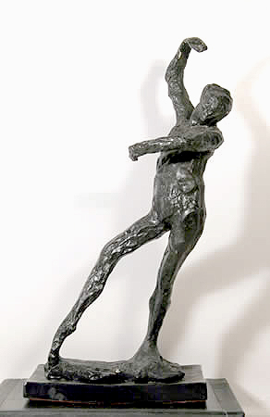
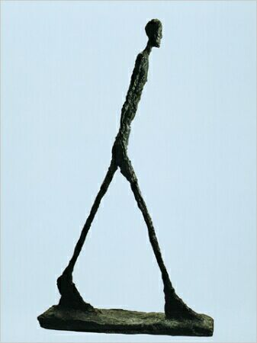

ART 10 COLOUR THEORY

I Colour Classifications
- Primary colours are red, yellow, and blue. These colours cannot be made using other colours, but can be mixed together to make all other colours.
- Secondary colours are orange, violet (purple), and green. These are made by mixing pairs of primaries (see colour wheel below).
- Colours may be arranged on a wheel.
P=Primary
S=Secondary
T=Tertiary

These are not the only possible combinations as there are an infinite number of colours between each colour shown on the wheel, and an infinite number of colour combinations across the wheel.

- Colour “Temperature” – Red, orange, and yellow are considered WARM, while blue, green, and violet are considered COOL. In general, every colour composition should have both warm and cool colours, though one may predominate. Keep in mind that these temperature classifications are general; ie., a colour’s temperature will always be affected by the colour(s) beside it, so that red may sometimes appear cool and green may sometimes appear warm.

II Colour Schemes (groupings)
Colour schemes are based on relationships of colours to one another, similarities and differences. Remember, as noted above, a colour is always affected by the one(s) placed next to it.

- Complementary colour scheme – 2 colours opposite on colour wheel; highest possible contrast. Complements bring out the best in each other; ie., red beside green looks as red as possible and vice versa. Illustrate on above wheel.
- Analogous colour scheme – 3 or 4 colours beside each on colour wheel; lower contrast. Illustrate on above wheel.
- Monochromatic colour scheme – variations of one colour (hue).
*NB Keep in mind this Rule of Contrast – The farther away from each other colours are on the wheel, the higher the contrast; the closer colours are together on the wheel, the lower the contrast.

III Colour Properties (ie., ways we describe or identify colours)

- Hue – colour name, eg. blue, red, orange, etc. Hue is changed by adding another colour.

- Value/tone – lightness and darkness of a colour; lighten by adding water (watercolour) or by adding white (acrylics, oils, tempera)

- Intensity – brightness and dullness. Dull a colour by adding its complement; eg., dull yellow by adding purple. A colour cannot be made brighter than it is.

*NB Make gray by mixing approximately equal amounts of complements – this will make a more natural gray and also allows for a greater of variety of grays than merely mixing black and white.

ART 10 WATERCOLOUR PAINTING

I What is Watercolour?

1. Watercolour is a transparent medium in which a small amount of pigment
(colour) is mixed with a lot of water.

2. Watercolour can be bought in small blocks or ovals, or in tubes. It is water
soluble.

3. Watercolour is cheaper than oils, is easy to transport, and is quick drying.
However, because it is transparent, mistakes are hard to cover.

II Materials Used In Watercolour Painting

1. Watercolour is usually done on heavy textured paper, which allows the artist
to move the pigment around easily before the water is absorbed; the highest
quality paper is handmade with a high “rag” percentage (instead of wood
pulp).

2. “Cold-pressed” paper is highly textured, because the wet pulp is formed into
flat paper in a cold press; “hot-pressed” paper, on the other hand, is very
smooth, the lumps in the pulp having been flattened out in a hot press.
Landscapes, or images with rough textured objects, tend to be best painted
on cold-pressed paper, whereas still lifes, or images with smooth surfaces,
are better on hot-pressed.

3. Watercolour brushes are soft and flexible; the best brushes are made of
real sable (certain hairs of a fox’s tail) and are, of course, very
expensive. Never leave a watercolour brush bristles-down in water.

III Three Watercolour Rules for Beginners

1. Work background to foreground.
2. Work from general areas to detailed areas (ie. usually details will be painted
last).
3. Work from LIGHT to DARK. Remember, you cannot lighten a dark colour,
but you can darken a light colour.

ART 10 CERAMICS

Clay is a special kind of earth that, when heated, retains its shape permanently. There are three main types of clay; earthenware, stoneware, and porcelain. Each type is hardened at a different heat, and when “fired” has a different quality. Earthenware and stoneware are coarser kinds of clay which are fired at 1800 – 2230 degrees F; porcelain is fine and translucent (ie. light can shine through it), and is fired at 2600 – 3400 degrees F.

As you can see, the clay is fired at a tremendously high heat. Firing can take anywhere from six to thirty-six hours. The earthenware pieces you will make take about 24 hours to fire, including heating up and cooling down time.

TERMS AND DEFINITIONS

- Wedging: the kneading process used to rid the clay of air pockets in order to prevent cracking in the kiln. Wedge for at least 10 minutes before forming.
- Slip: the creamy “glue” made of clay and water used to join pieces of clay.
- Kiln: the special, highly-insulated oven for firing clay.
- Leatherhard: the stage in drying in which the clay can support itself, but is not thoroughly dry and therefore not ready for firing.
- Greenware: the state of clay when it is dry and ready to be fired, but is not fired.
- Bisque Firing and Bisqueware: the first firing after clay has been dried; the state of the clay after first firing.
- Glaze Firing and Glazed Ware: the second firing after bisqueware has been glazed (optional), and the state of the clay after glaze firing.
- Glaze: the glassy or matte surface of the pot. Its raw state consists of a mixture of powdered glass, fluxes (the ingredient causing the glass to melt) and colourants, in water. It can be painted or poured on.

IMPORTANT NOTES

- Greenware is fragile and cannot be repaired if it breaks. BE CAREFUL.
- If the clay feels cool on your cheek, it is still leatherhard (ie. there is still moisture in it); when it is room temperature, it is greenware, and ready for firing.
- Avoid breakage in the kiln:a) no parts should be thicker than ½”
b) keep your pot under the plastic sheet so it dries
slowly.
c) make sure your structure supports itself absolutely.
4. DO NOT GLAZE the bottom of your pot; it will melt to the kiln! DO apply three
coats of glaze.
5. Please store your unfinished pot and unused clay in a sealed plastic bag over-
night; it is also helpful to wrap it in a wet paper towel before putting it in the bag.

THREE METHODS OF CONSTUCTION
- Pinch Pot
- Coil Pot: this method can be used to make pots several feet high.
- Slab Pot: ideal for angular pieces. Clay is rolled out to an even thickness, cut to shape, and joined with slip.
ASSIGNMENTS

1. Make a small clay slab, either a wall-hanging or a hot-pad. It can be any shape; should be no more than ½” thick, and must have some sort of decorative design on it.

2. Built a pot. It must be functional, ie. you must be able to use it, such as a vase, a mug, or a container for odds and ends, etc. Use either method #2 or #3 above; it must include some form of decorative design (see below). Be imaginative!

DECORATIVE IDEAS (See books – Clay: Hand building and Decorating Pottery)

- Press soft clay from inside out to form lumps or ridges.

- Press clay from outside in to change basic shape.

- A design may be added using thick clay slip. Mix slip and put it into a plastic bag with a small hole at one end. Squeeze design onto a piece of newspaper. Apply newspaper with design to pot and press on.

- Be flexible in your use of tools. As well as hands, consider knives, spoons, forks, toothpicks, paintbrushes, etc. for forming.

- The above tools may be used for texturing, as well as any object that will form a relief print, eg. leaves, pinecones, sticks, shells, feathers, screening, sandpaper, spools, bark, driftwood. Objects may be pressed into the soft clay to form a regular pattern.

ART 10 PRINTMAKING

What is Printmaking? The process of producing on a surface the impression of an inked master, usually called a “plate” or “stencil”. Printmaking differs from drawing and painting mainly in that multiple, exact copies can be made; it is also tends to be less spontaneous since it is an indirect method of making art.

Four Printmaking Processes (Draw in illustrations of each method)

- Relief – raised/top areas print; master is called a “plate”; examples of reliefs prints are linocuts, woodcuts, potato prints, thumbprints, stamps, etc.

- Intaglio – opposite of relief, lower areas print; master called “plate”; examples of intaglio are engravings and etchings.

- Stencil – cut away/open areas print; master called a “stencil”; examples of stencil are paper or cardboard stencils and silk screen (serigraphy).

- Planographic – prints what is drawn on the surface; master called “plate”; examples are monoprints and lithographs.

Terms and Definitions for Linocuts

- Plate – master with your design from which prints are made.
- Gouger/veiner – large/small carving tools
- Brayer - roller used to spread the ink on the plate.
- Ink – colour medium (water soluble acrylic)

