ART 10 STUDIO ASSIGNMENTS

FIGURE DRAWING – Gesture, contour-gesture drawings. Done as a class. Hand in all drawings.

CONTOUR DRAWING – Drawing of plant or flowers (set up in class). Fine marker only, no pencil.
3-credit: 9” x 12” 5-credit: 12” x 18”

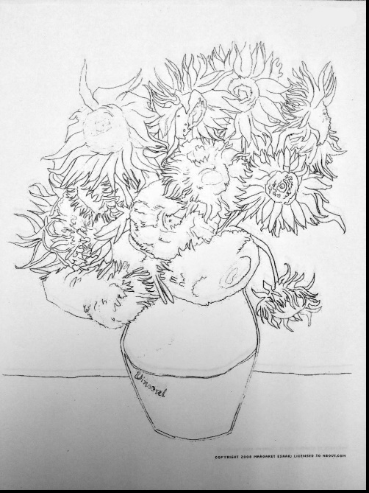

MODELLED DRAWINGS – Drawings of three pieces of fruit. Pencil or charcoal.
5-credit: Pencil – 4.5” x 6” Charcoal – 9” x 12”
3-credit: Choose either pencil OR charcoal and complete one drawing.

MEDIA ASSIGNMENT

- In your sketchbook you will practice your technique in the following media, creating colour mixes and tone scales, and practicing modelling: chalk and oil pastels, conte, pen &ink, charcoal pencil.

- Create visual representations of the following themes. If you are 5-credit, you will do all 7, if 3-credit, you will do your choice of 4. Your themes may be representational (ie. look like the real thing), abstracted (be based on the real thing but changed to make image stronger and more expressive), or nonobjective (based on elements of art, nothing “real”).

- Abandoned
- Drip, Dribble, or Splash
- Creation
- Freedom
- Through a Window
- Jazz
- Questioning

- You MUST:
Use a variety of papers (available in box provided)
Limit your colour schemes to 3-5 colours, not including black and white
Cover the surface with your medium (if using pen&ink, create a ground first in a different medium).

- Your GOAL:
Competent use of medium
Good, effective compositions
Flexibility in combining media
Imaginative solutions

The following two assignments are based on your media studies. If you are in 5-credit Art you will do both of them, in which case you must choose different media or combinations of media for each one. If you are in 3-credit Art you will choose either the poster OR abstracted self-portrait.

POSTER ASSIGNMENT 12” x 18”

Create a poster which includes the quotation: “Life is Better with Art in It”. If you would prefer to choose a quotation of your own you may do so, but be sure to check it with the teacher first.

You may use any of the media you used in the theme assignment, and you are strongly encouraged to mix your media.

The same requirements apply as in the theme assignment.
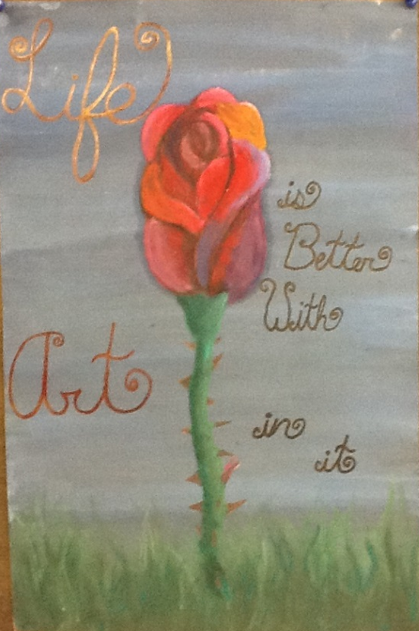

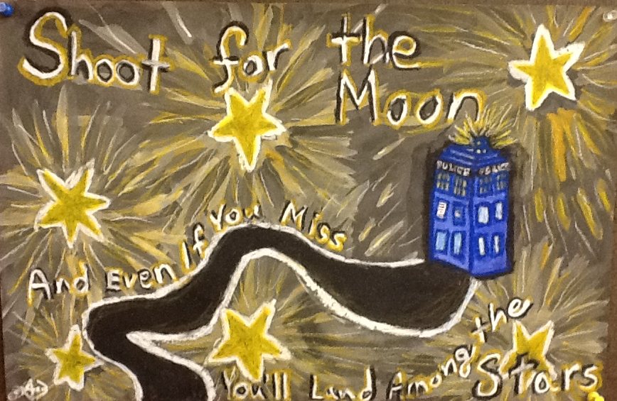

ABSTRACTED SELF-PORTRAIT ASSIGNMENT

Size: 12” x 18”
You will create a portrait of yourself, head and shoulders only, which may be abstracted using any of the abstraction methods, or combination of methods, studied in class. You must choose a specific mood (list of suggested moods below – do not divulge your chosen mood to anyone else), and execute your piece using any of the media, or combination of media, we have used in class; you may also include one or more collage elements.

Steps
- Choose your mood.
- Get a picture of yourself in your desired pose and with desire facial expression.
- If you want some ideas, google images: “abstracted portraits”.
- Create an “underdrawing” of your portrait using light-coloured chalks, using your photo as a guide (remember, this is not “realistic”, so the photo is definitely only a guide).
- Complete your portrait in chosen medium/media.

List of Moods: melancholy, excitement, anxiety, sorrow, despair, joy, serenity, fury, discontentment, distress, exuberance.

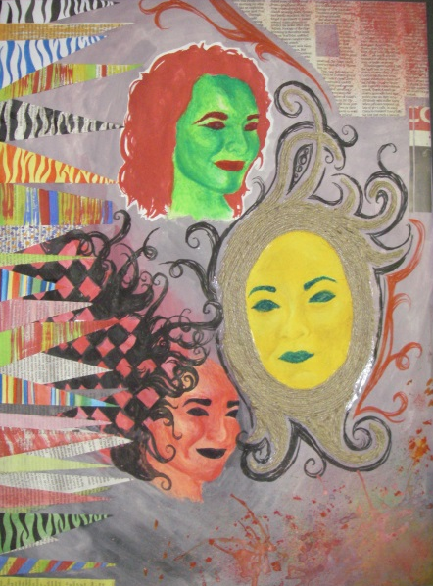
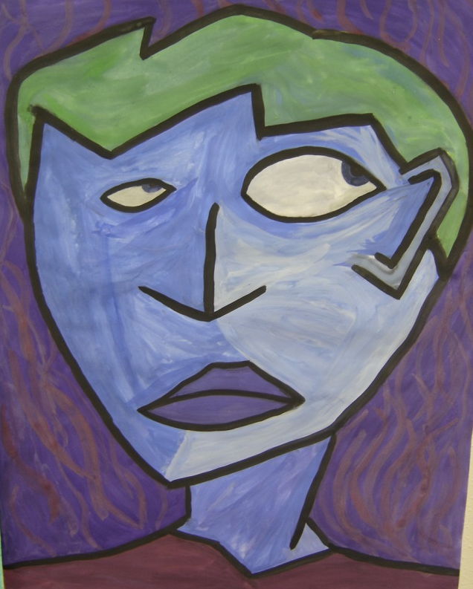

SCULPTURE ASSIGNMENT PAPIER MACHE FIGURE (3 and 5-credit)

- Decide on your figure’s pose. Your goal is a credible, convincing pose showing movement.

- If necessary, on scrap paper draw sketch of pose idea.

- With wire, build your ARMATURE (ie. skeleton for support) in the pose you desire. Make sure it is balanced.

- Cover wire the papier mache. You may use the paper pulp mixed with water to make a paper clay, or newspaper strips with flour and water glue, or a combination. Make sure body and limbs are the thickness that is best suited to your figure.

- Dress your figure. Create clothing from fabric with the desired texture(colour and pattern will not show); make hair from wool. Before putting it on your figure soak it in glue, so that it will be totally hard when dry.

- Nail your figure to a wooden base at the appropriate time. When it is completely dry, spray paint it in either black, gold, or both. Remember to paint the top and sides of the base.

WATERCOLOUR UNIT (5-credit; 3-credit if time)

I Watercolour Techniques
- Flat Wash – area of even colour; mix lots of wet paint; stroke colour onto paper, should leave a ”bead” of colour to pick up with next stroke: tilt paper to ensure even spreading and no “water marks”.
- Graded Wash – wash changing from dark to light; mix up strong colour; stroke strong colour onto paper (should be a bead as in a.); gradually add water to brush, diluting the colour; tilt paper; aim for an even grade from dark to light.
- Wet-in-Wet – mix up strong colours; brush paper with clean water and let it soak in a little; paint on paper while still wet.
- Blotting – paint paper with strong colour, using any of the above techniques. Use scrunched up paper towel to pull off colour for textured effects.
- Salt – paint strong, fairly wet, colour on paper; sprinkle salt on sparingly; let dry completely, then brush off salt.

II Watercolour Practice

Using compositions of simple 3D shapes (spheres, pyramids, cubes), one or two shapes per composition, practise all of your techniques until you have some proficiency in them all. You should be doing 3 or 4 at least.

III Major Assignment
TBA in class.

CERAMICS (3 and 5-credit)

1. Make a small clay slab, either a wall-hanging or a hot-pad. It can be any shape; should be no more than ½” thick, and must have some sort of decorative design on it.

2. Built a pot. It must be functional, ie. you must be able to use it, such as a vase, a mug, or a container for odds and ends, etc. Use either method #2 or #3 above; it must include some form of decorative design (see below). Be imaginative!

DECORATIVE IDEAS (See books – Clay: Hand building and Decorating Pottery)
- Press soft clay from inside out to form lumps or ridges.

- Press clay from outside in to change basic shape.

- A design may be added using thick clay slip. Mix slip and put it into a plastic bag with a small hole at one end. Squeeze design onto a piece of newspaper. Apply newspaper with design to pot and press on.

- Be flexible in your use of tools. As well as hands, consider knives, spoons, forks, toothpicks, paintbrushes, etc. for forming.

- The above tools may be used for texturing, as well as any object that will form a relief print, eg. leaves, pinecones, sticks, shells, feathers, screening, sandpaper, spools, bark, driftwood. Objects may be pressed into the soft clay to form a regular pattern.

LINOCUT/BLOCK PRINTING (5-credit; 3-credit if time)
- Trace your lino-block on a piece of scrap paper.

- Create design. Design ideas:
Natural objects – plant, animal, bird, fish, fruit, vegetable (abstracted or stylized)
Design based on a theme – eg. Youth, Age, War, etc.
Abstraction/stylization of the sun/moon.
Your own idea.
You may include words but make sure you draw them backwards!
NO commercial logos or symbols; no copying anybody else’s design.

- Carve out your design using gaugers and veiners. Remember, the raised areas will be ink colours, the carved out parts the colour of the paper. Warming up your plate with the iron will make it softer and easier to carve – but don’t use it when you are corving out detailed areas as you may end up cutting out more than you intended.

- Print your plate. Make a minimum of 10 prints. Be creative with your colours and techniques.

- Hand in your three best prints. Sign them in pencil at a bottom edge outside the edges of the print.

