ART 20 ASSIGNMENTS
5 – Credit students are required to do all assignments; 3 – credit students are required to do #1,2,3,5,6, and your choice of 7 or 9.
- Figure Drawing – gesture, contour-gesture, contour, partially-delineated. As a class. Hand in all drawings.
- Contour Drawing – footwear with scarf. In SB/journal. Fine marker only (ie. No pencil)
- Modelled Drawing (practice only, not marked) – piece of fruit in 3 different media (choose from drawing pencil, charcoal, charcoal pencil, chalk/oil pastel, conté), in SB.
- Figure drawing composition – In journal. Choose a partner. Draw your partner in your SB and build a composition around him/her. Choice of drawing medium.
- Perspective Drawing –A corner of the classroom. Use a ruler to draw lines to vanishing points. Go over lines freehand with fine marker and add a single colour watercolour wash. (9”x12”)
- Major Drawing Assignment – this drawing is designed to give you an opportunity to put your knowledge of drawing, composition, modelling technique, tone and perspective into practice in one assignment. Choose your drawing medium or combination of media.
5 –credit: 18” x 24” 3 – credit: 12” x 18” White or gray drawing paper.
Choose a chair. You may use a chair in the classroom, take a picture of a chair from home, or find a chair you like on the internet and print it off. Create a composition based on the chair, which must be placed on an angle so that it is in perspective. Add whatever you would like to the chair to make a visually stimulation composition. Your chair should fill your compositional space.

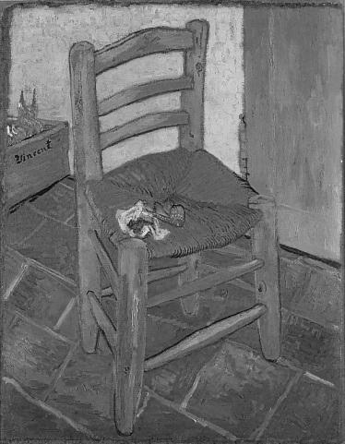
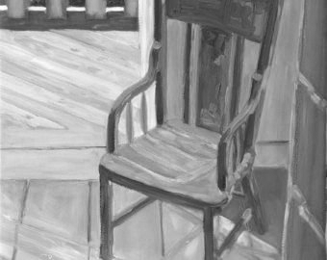
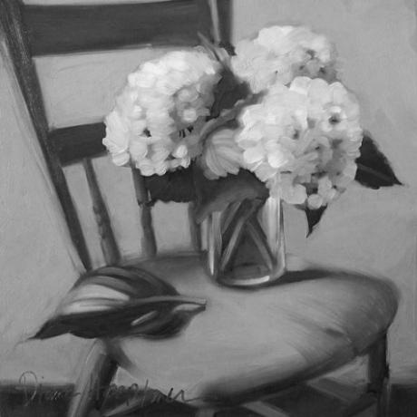

- Watercolour/acrylic Unit (See attached sheet)
- Screen Printing Assignment (See attached sheet)
- Final Acrylic Painting (See attached sheet)

ART 20 WATERCOLOUR/ACRYLIC UNIT
- (Omit this is you did it in Art 10)
Watercolour colour mixing. Make 10 mixes of each, including the pure colours.
- Blue + yellow
- Yellow + red
- Blue + red
- Red + blue + yellow Mix all three, keeping them looking like colours and not browns or grays.
- Red + blue + yellow Mix all three so they are neutrals, ie. grays and browns.

- Watercolour techniques: on a large sheet of watercolour paper experiment with the following techniques.
- Flat wash – even colour, tilt paper.
- Graded wash – dark to light; tilt paper.
- Wet-in-wet
- Glazing: paint a thin wash, then let dry; paint another thin wash on top of the first one in a different colour, let dry; paint a third, and so on.
- E. pen and ink: draw with ink, then paint, and vice versa; combine with wet-in –wet.
- Spongeing: apply colour with a sponge for textured effects.
- Crayon/pastel resist: draw firmly with crayon or oil pastel, then paint over (be sure to use contrasting colours!)
- Salt: sprinkle sparingly on wet, dense colours, and brush off when dry.
- Wax paper: paint with wet, dense colours; lay crumpled paper on top and let dry thoroughly.
- Masking: use tape to block area, then paint over and remove tape when dry. You might want to also try this with rubber cement.

- Acrylic colour mixing (same as w/c)

- Acrylic techniques: draw 4” x 5” boxes for the following.
- Mix from one colour to another
- Mix from dark to light of one colour
- Use acrylic thinly like w/c
- Create textured surface with putty and paint on it.

- Themes: Choose 5 of the following. Must use both kinds of paint and all techniques at least once. Use variety of surfaces from those provided.

- Celebration b. Tragedy c. Distortion d. Water d. Shattered Images

- Boxes f. Tools g. Hands h. Paint i. Butterfly

- Major Assignments: Two 9” x 12” paintings Stretch one sheet of w/c paper ahead of time.
- Watercolours: RECREATE a black and white photo of a simple still life (find one online). Must be clearly lit from one side. Come up with an effective colour scheme. Must use one or more w/c techniques. Show accurate light effects.
- Acrylics: Paint a close-up of a self-portrait (a section from a head and shoulders only portrait). Does not have to be realistic colour. May combine collage or some textural element. May use acrylics any way you like. Take photo of self, transfer section to paper (consider pose, angle, facial expression carefully; portrait should take up most of compositional space).

ART 20 SCREEN PRINTING ASSIGNMENT

Choose poem, quotation, or Bible verse.

Create a design which includes the above and covers your printing surface. Your image should complement your text.

Follow photo emulsion method as printed on separate sheet to prepare your screen.

Prepare your background sheets. This step is very important, as the colours and methods you use on these sheets are what set the tone for your design. Spent time thinking about how to make these most effective. I recommend you prepare at least 10 sheets, and that you have a variety of colours.

Print your design on your dried background sheets. When they are completely dry, mount 2 or 3 of your best ones.

Example:
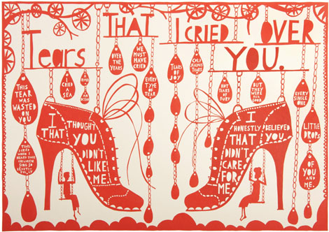

ART 20 Painting Assignment

Your final major project will be a painting in acrylics.

Choose from the following themes:
- My Refuge
- Standing Still
- The Game of Life
- Out of Place
- Perspectives

Tasks:
- Once your theme is chosen, you need to come up with ideas and makes some sketches. If your idea includes a figure, I suggest you have someone pose for you and do some practice figure drawings. This will contribute greatly to your authenticity.
- Set up your scene in real life and photograph it, OR search for photos you can use and assemble them. You may make some changes to this, but you must have a clear visual reference to work from.
- Although you may assemble your images unrealistically, your piece should otherwise be fairly naturalistically painted, ie. if you abstract at all it should be minimally, except in the case of colour, which you may change to suit your purposes.
- Make some colour sketches in watercolour to plan your colour scheme.
- Prepare your canvas with a light ground colour.
- Sketch your underdrawing in the ground colour paint, or in chalk.
- Begin painting.

Things to Keep in Mind:
- Lighting is very important, so pay attention to it and keep it consistent. It can be very significant in setting the mood.
- Remember to paint over the whole composition simultaneously, rather than completing one part at a time. Best to start with the background.
- Keep your colour scheme tightly controlled. Repeat colours throughout for colour balance and unity.
- You might find it helpful to get some ideas online, but don’t be tied to what you see; work on developing your own style.

