Art 20
NOTES
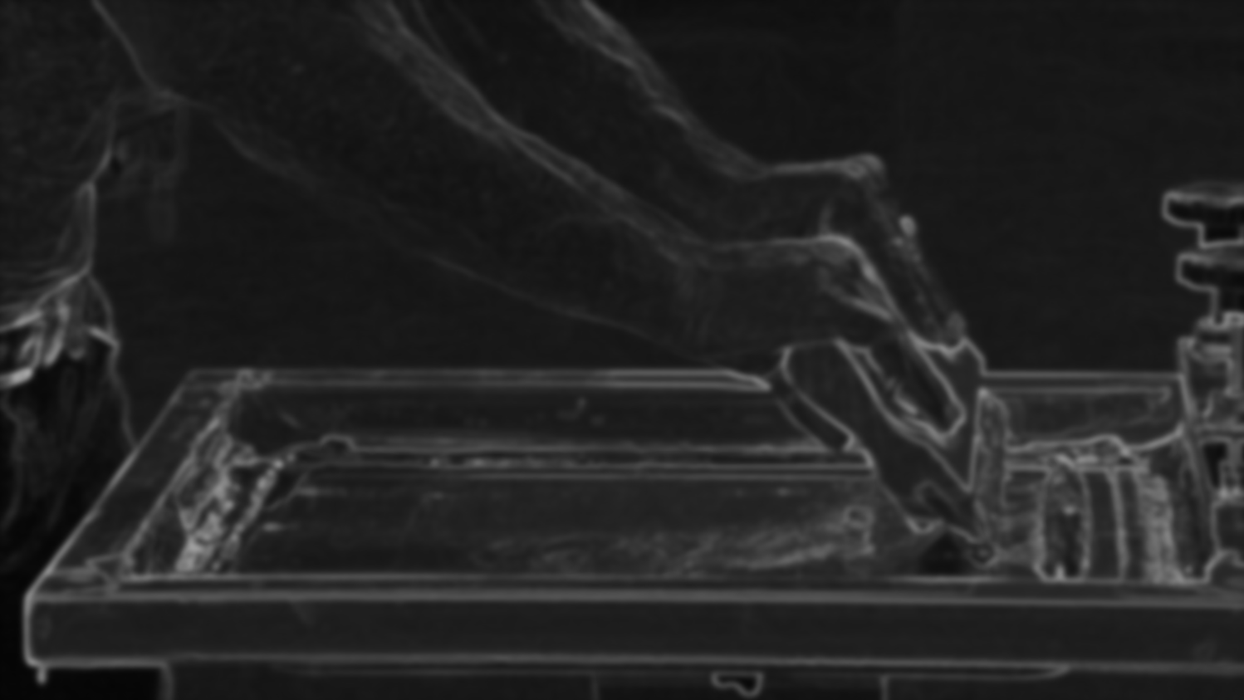

Name ______________________________

ART 20 COURSE OUTLINE Semester 1 2018-19

Art 20 builds on skills and knowledge gained in Art 10, and moves beyond, demanding more of you technically and imaginatively. You will be expected to work more independently at this level, (since the Art 10s usually require more attention). The following outline is very general, allowing for changes and additions to be made as required or allowed by extra time we may have available. Art 20 may be taken either as a 5-credit or a 3-credit course; if 3-credit you will do a little more than half the following.

Unit I Foundations Review

A. Composition exercises to improve unity: still life drawing, photography;
principles and elements of design review.

B. Proportion and Perspective: drawing review; figure drawing; perspective
drawing.

Unit II Beyond Foundations

A. Watercolours

B. Screen Printing

C. Acrylics

D. 3D, if time.

There will be critiques throughout the course in order to improve your work by looking at others and discussing it, and in order to improve and increase your art vocabulary.

SKETCHBOOKS(SB)/VISUAL JOURNALS: Please read this carefully!

Please have your SB with you in class at all times, but also take it home in order to complete your sketchbook assignments.
REQUIREMENTS: 5-credit students – 20 drawings; 3-credit students – 14 drawings. At least half your drawings should include elements from life (they may be combined with imaginative elements). Choose your own assignments from the list provided (it will also be posted in the classroom and on Weebly). Please include with each drawing: the # of the assignment, your signature, and the date you completed the drawing.
I will be marking your sketchbook/journal only twice; once at the end of the each quarter. It is worth 25% of your term mark. I will not formally check your assignments but I will be looking in your sketchbooks informally on a regular basis.
You will also use your sketchbook for information, thumbnail sketches, and various studies in preparation for larger pieces.

PORTFOLIOS
Please keep all your studio work in your portfolio, unless it is on display. Due dates for studio work will be given in class. Late marks may be deducted if you procrastinate finishing work (you may have to put in some extra time to finish).

NOTEBOOKS
All handouts will be provided at the beginning of the course in a duotang. Please leave the duotang in class unless you are studying for a quiz.

QUIZZES
Instead of major tests, you will have a series of short quizzes throughout the semester. You will have a final exam.

ABSENCES
It is very important that you be in class every day in order to complete your studio work. Excused absences include illness, funeral attendance, and special family occasions such as weddings and graduations; in these cases you will not be required to make up class time, unless you have previously fallen behind. Unexcused absences include shopping, ski trips, extra holidays, “stress days”, leaving early for breaks and coming back late from breaks, and probably a dozen more reasons you can think of: in these cases you will be required to make up your time, and you are entirely responsible to find out what you have missed on your own.

SUMMATIVE ASSIGNMENTS (required for course completion for 5-credit; 3-credit will complete 5 of these, plus SB)
1. Contour drawing
2. Modelled drawing assignment
3. Value/Lighting Composition
4. Figure drawings
5. Watercolour/acrylic studies
6. Screen print composition
7. Acrylic painting
8. 3D piece (tentative)
9. Completed sketchbook

EVALUATION
Quarter Grade: quizzes 15%
sketchbook 25%
studio 60%
100%

Final Gade: Quarters 3 and 4 85%
Final Exam 15%
100%

ART HISTORY

ART HISTORY OUTLINE Modern Art: 1750 to mid-20th Century
1. The Modern World: Neoclassicism
2. Romanticism
3. Realism
4. Impressionism
5. PreRaphaelite Brotherhood
-----------------------------------------
6. Post-Impressionism
7. Pablo Picasso
8. Expressionism, etc.
9. Dada and Surrealism
10. Pop, etc.

ART HISTORY OUTLINE 20th Century Canadian Art
Canadian Overview: 1600s-1800s
J.W. Morrice (video)
Tom Thomson and The Group of Seven
Emily Carr: Growing Pains and The Little Old Lady on the Edge of Nowhere
(video)
Discussion of Emily Carr with filmstrip.
David Milne (film and filmstrip)
A.J. Casson: The Only Critic is Time (film)
Jack Bush (film)
Paul-Emile Borduas (film)
Alex Colville: The Splendour of Order (video)
Riopelle (film)

ART 10/20/30 COMPOSITION/ELEMENTS/PRINCIPLES in ART

I What is composition?
The organization and arrangement of the visual elements (ie. line, shape, value/tone, colour,
texture) in a work of art in a unified way. All 2D art can be analyzed by these standards,
whether representational or non-objective, or anything in between.

II Elements – ie. tools or ingredients of art

1. LINE- expressive of mood; leads eye through comp.; creates movement, creates structure, pattern, texture, shape, tone.

2. SHAPE – all objects can be reduced to simple shapes, whether geometric or organic. Shape can be distinguished by all other elements.

3. TEXTURE – visual or tactile (seen or felt); create with all other elements.

4. TONE/VALUE – lightness and darkness – helps create mood, focus, pattern, rhythm,
form (modeling).

5. COLOUR – mood, symbol, light, movement, creates form.

III “Preliminaries” or Foundational principles of 2D art

1. PICTURE PLANE – FLAT surface artist works on; may be treated anywhere from 2D (usually
decorative) to 3D (illusionistic, like a window), and anywhere in between.

Picture Plane is
2D, ie. unbroken. Picture Plane is 3D, ie. broken.

2. FRAME SHAPE – boundaries of picture plane; shd fit comp; rectangle most common.

3. POSITIVE AND NEGATIVE SHAPE – positive is what is first laid down by artist; negative is“leftover”;
can be clearly pos or neg; can flip-flop; can be ambiguous.
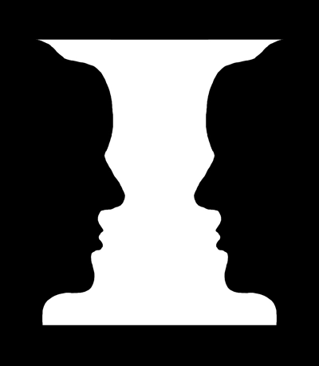
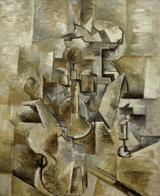
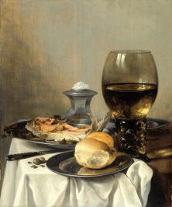

4. PERSPECTIVE – showing (illusion of) depth on flat surface by various methods.

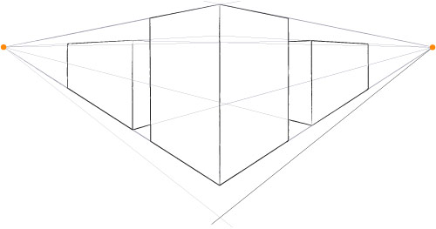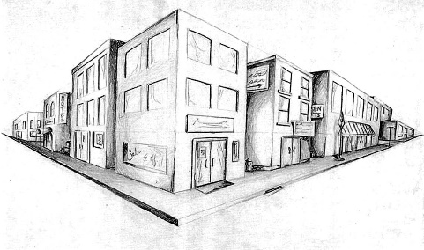

IV Principles – guidelines for using tools
- FOCAL POINT – starting pt./resting pt. from which all eye movement begins.
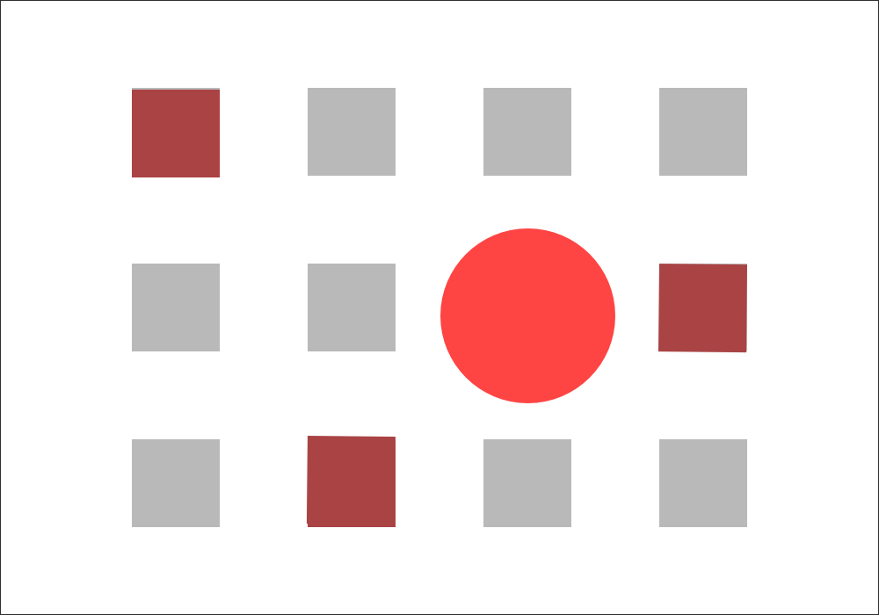

2. Movement – the visual movement directed by the artist to bind the parts “…should
assure that all areas of the picture plane are exploited, ie. that there
are no DEAD SPOTS…by directing shapes and lines toward each other…
so that the spectator is unconsciously swept along visual channels”.
(Art Fundamentals, p.34)
What hinders movement? 1) object(s) in middle of picture plane
2) repeating frame shape within plane
3) empty space at edges – if you can cut off edges without affecting the
comp., movement not working.

3. SAMENESS/REPETITION – repeating elements (whether shapes, colours, lines, etc.); not always
exact duplication, but similar. Rhythm through repeated elements helps create movement.
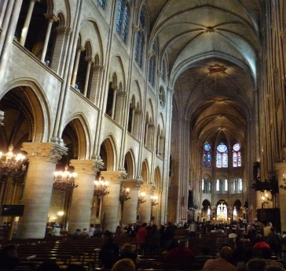
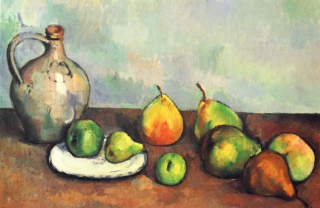

4. VARIETY – opposite of harmony; contrast, differences to add interest. Eg. varying heights of objects
(simple triangular comp, 3 objects, 3 heights, usually works well)
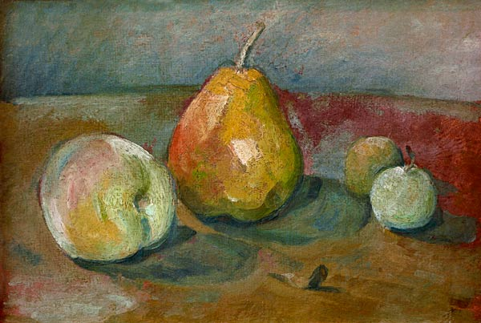

5. BALANCE – visual equality (in attention) on both sides.
a. symmetrical – same arrangement of elements on both sides.
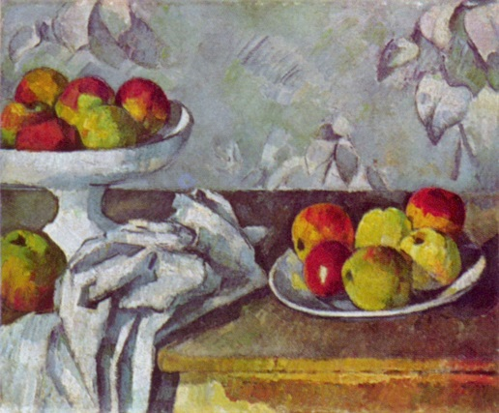
b. asymmetrical – different arrangement. More interesting. Hint: use odd number of objects.
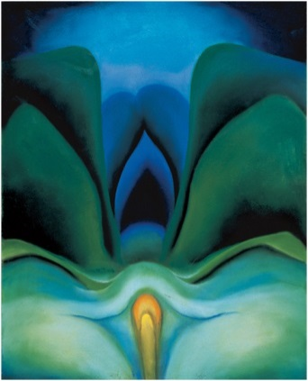
.

6. UNITY – total effect of all parts working together; “comfortable” compositions have unity.

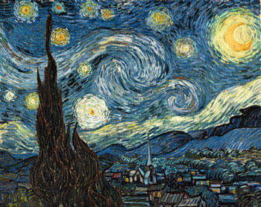

ART 20/30 DRAWING METHODS (See your sketchbook/journal for examples)

- GESTURE: A quick, spontaneous method focusing on the “inner energy” of the form rather than the edges. Keep drawing tool on surface until drawing complete.

- CONTOUR: Drawing only the edges/outlines of the subject; a slow, deliberate method; aim for a smooth, confident line as opposed to a broken “scrubbed” line.

- Blind Contour: Drawing subject looking ONLY at the subject, not at your paper.
- Modified Contour: Drawing subject looking MOSTLY at the subject, a bit at your paper.
*SIGHTING: A technique used to improve proportion; using your finger or pencil to measure sections of your subject in comparison to other sections.

- CONTOUR-GESTURE: A free, energetic drawing which touches the edges. Best not to remove drawing tool from surface until drawing complete.

- MODELLED/MASS: A drawing which is shaded (ie., using a variety of tones) to give a sense of solidity, mass, weight. Tonal changes are influenced by light and texture.

Some modeling methods and suggested media:
- Smudging – charcoal, conté
- “Shading” – pencil, conté, coloured pencil
- Hatching/Cross-hatching – pen and ink, pencil, marker, ballpoint pen
- Stippling – pen and ink, marker, ballpoint pen

PARTIAL DELINEATIONS (“Incomplete” drawings): Parts of images may be left undrawn, ie., only partially delineated, in such a way that the area left out is completed in the “mind’s-eye” of the viewer. A partially delineated drawing involves a strict economy of line; the lines/shapes that are drawn must be sensitive and accurate. These drawings should look fresh and spontaneous as opposed to over-worked and heavy.

ART 20, 30 PERSPECTIVE (Methods of showing depth on a 2D surface)

Principles of Perspective
- Objects up close are larger than objects of the same size farther away.

- Objects up close are lower on the paper; objects farther away are higher on the paper.

- Objects up close overlap objects that are behind them.

- Objects up close usually appear darker and more vivid than objects in the distance which are lighter and hazier. This is called ATMOSPHERIC PERSPECTIVE.

- Parallel lines converge (come together) at the horizon line. This is called LINEAR PERSPECTIVE. There are 3 methods used to create linear perspective.

- One-Point = one vanishing point (*NB. All corners of cube are vertical.)

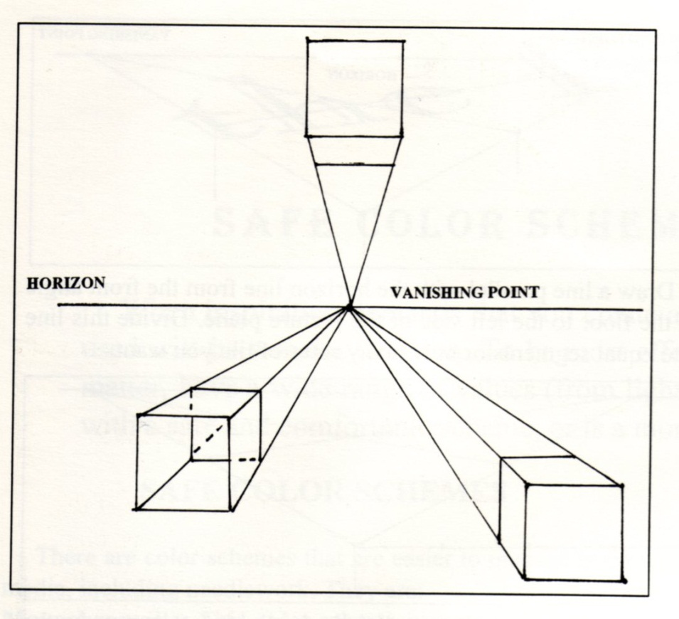

- Two-Point Perspective = two vanishing points (*NB. All corners are vertical and all sides converge at horizon line.
Exterior Interior
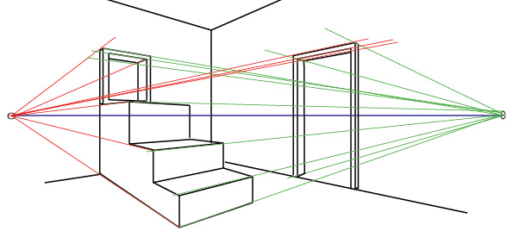
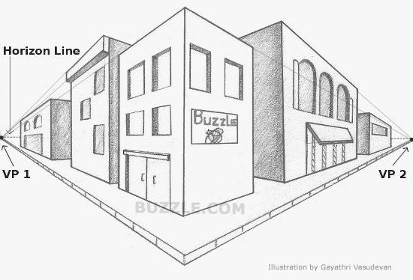

- Three-Point Perspective = three vanishing points (*NB. May be one or no vertical corners and all sides converge in three directions.)

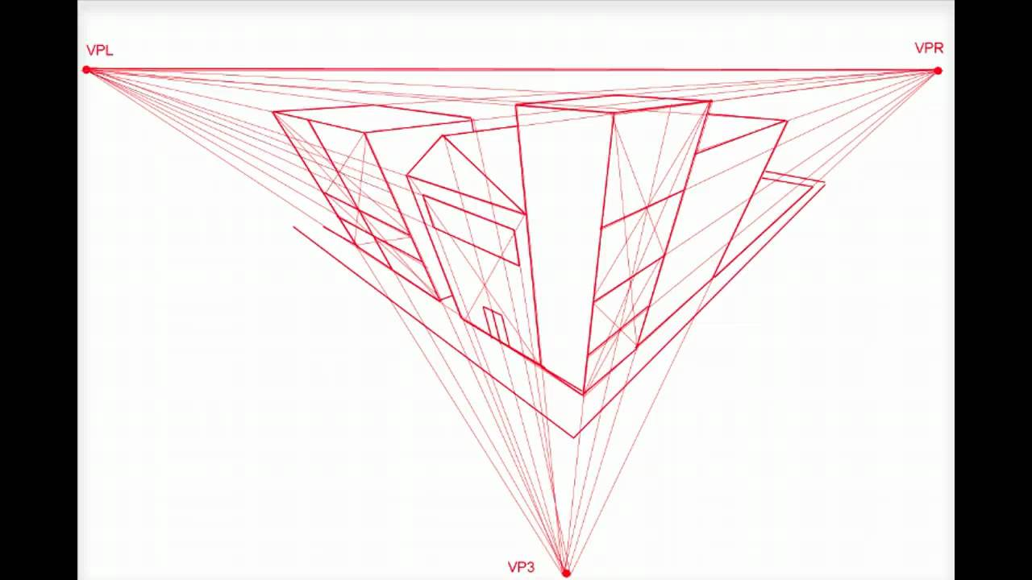

ART 20, 30 PERSPECTIVE (Methods of showing depth on a 2D surface)

Principles of Perspective
- Objects up close are larger than objects of the same size farther away.

- Objects up close are lower on the paper; objects farther away are higher on the paper.

- Objects up close overlap objects that are behind them.

- Objects up close usually appear darker and more vivid than objects in the distance which are lighter and hazier. This is called ATMOSPHERIC PERSPECTIVE.

- Parallel lines converge (come together) at the horizon line. This is called LINEAR PERSPECTIVE. There are 3 methods used to create linear perspective.

- One-Point = one vanishing point (*NB. All corners of cube are vertical.)

- Two-Point Perspective = two vanishing points (*NB. All corners are vertical and all sides converge at horizon line.
Exterior Interior

- Three-Point Perspective = three vanishing points (*NB. May be one or no vertical corners and all sides converge in three directions.)

ART 10,20,30 ABSTRACTION METHODS (See Presentation on Weebly for examples)
What is Abstraction?
Abstraction comes from the verb “to abstract”, which means “to take away from”. True abstract art, then, always begins with something from real life which the artist changes in some way. There are four main ways artists abstract things from real life.

- SIMPLIFICATION: Taking away details, flattening 3D objects into organic or geometric shapes; flattening colours

- DISTORTION: Making specific parts bigger, longer, smaller; twisting or “melting”; drastically changing texture or colour.

- EXAGGERATION: Magnifying or multiplying object; making object significantly smaller.

- REARRANGEMENT: Taking object apart and reassembling it in a new way; showing more than one point of view at a time.

What is Nonobjective Art?
Art which has as its source something NOT from real life is called “Nonobjective”, literally “no object”. Nonobjective art focuses instead on the elements inherent in art, ie. line, shape, colour, tone, texture, space.

ART 10,20,30 PORTRAIT PROPORTIONS (The proportions of the human face)
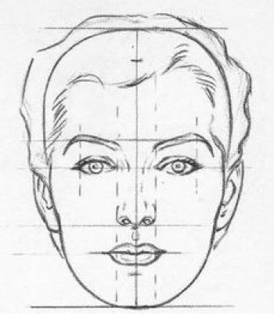

THINGS TO REMEMBER!!
- Midpoint of eyes is halfway between top of head and bottom of chin.
- Bottom of nose is halfway between midpoint of eyes and bottom of chin.
- Width of nose = space between eyes.
- Ears generally lie between midpoint of eyes and bottom of nose.
- Neck is drawn from jawline gradually widening toward shoulders (not in drawing).

ART 20 COLOUR THEORY

I Colour Classifications

- Primary colours are red, yellow, and blue. These colours cannot be made using other colours, but can be mixed together to make all other colours.
- Secondary colours are orange, violet (purple), and green. These are made by mixing pairs of primaries (see colour wheel below).
- Colours may be arranged on a wheel.
P=Primary
S=Secondary
T=Tertiary

These are not the only possible combinations as there are an infinite number of colours between each colour shown on the wheel, and an infinite number of colour combinations across the wheel.

- Colour “Temperature” – Red, orange, and yellow are considered WARM, while blue, green, and violet are considered COOL. In general, every colour composition should have both warm and cool colours, though one may predominate. Keep in mind that these temperature classifications are general; ie., a colour’s temperature will always be affected by the colour(s) beside it, so that red may sometimes appear cool and green may sometimes appear warm.
Warm colours tend to appear closer, larger, and lighter in weight; cool colours tend to appear farther away, smaller, and heavier.

II Colour Schemes (groupings)
Colour schemes are based on relationships of colours to one another, similarities and differences. Remember, as noted above, a colour is always affected by the one(s) placed next to it.

- Complementary colour scheme – 2 colours opposite on colour wheel; highest possible contrast. Complements bring out the best in each other; ie., red beside green looks as red as possible and vice versa. Illustrate on above wheel.
- Analogous colour scheme – 3 or 4 colours beside each on colour wheel; lower contrast. Illustrate on above wheel.
- Monochromatic colour scheme – variations of one colour (hue).
- Triadic – 3 colours equidistant from each other on the wheel, ie., forming an equilateral triangle, eg. red, yellow, and blue; fairly high contrast.

*NB Keep in mind this Rule of Contrast – The farther away from each other colours are on the wheel, the higher the contrast; the closer colours are together on the wheel, the lower the contrast.

III Colour Properties (ie., ways we describe or identify colours)

- Hue – colour name, eg. blue, red, orange, etc. Hue is changed by adding another colour.

- Value/tone – lightness and darkness of a colour; lighten by adding water (watercolour) or by adding white (acrylics, oils, tempera)

- Intensity – brightness and dullness. Dull a colour by adding its complement; eg., dull yellow by adding purple. A colour cannot be made brighter than it is.

*NB Make gray by mixing approximately equal amounts of complements – this will make a more natural gray and also allows for a greater of variety of grays than merely mixing black and white.

IV Compositional Principles

In order to achieve colour harmony/sameness, repeat colours.

In order to achieve colour balance, use similar colours on both sides of picture.

In order to achieve colour unity, limit hues to from 3 to 5 (not including black, white, or gray).

ART 20 PAINTING NOTES (Watercolour and Acrylics)

I Watercolour Painting

Characteristics:

1. Can be bought in blocks or tubes.
2. Water soluble; small amount of pigment mixed with a lot of water.
3. Transparent medium; layers of washes; mistakes hard to cover.
4. Cheaper than oils; easy to transport and quick-drying.

Materials:

1. Usually done on heavy textured paper; best paper is handmade with a high
“rag” percentage (as opposed to wood pulp).
2. “Cold-pressed” paper is highly textured; “hot-pressed” less so.
3. Brushes are soft and flexible; best brushes made of real sable (certain hairs in
a fox’s tail); brushes should never be left bristles down in water.

Painting Process:

1. Underdrawing in hard/light pencil.
2. Large areas washed in first, then work to details.
3. Work light to dark, as light colours will not cover dark ones.
4. White paint is rarely used, but rather the white of the paper is left for highlights.

II Acrylic Painting

Characteristics:

1. Is a synthetic paint; acrylic resin binds pigments.
2. Oil-like consistency, but can be used like oil or watercolour.
3. Is water soluble and is thinned with water for w/c use; mix with acrylic medium
to slow drying time.
4. Almost as expensive as oils.
5. More resistant to heat and light and climate than oils (not yet time-tested over
centuries).

Materials:

1. Same as w/c if used as such, ie. paper and brushes.
2. When used as oils, generally done on a heavy, nonabsorbent surface, such as
canvas, canvas board, wood, masonite, or cardboard.
3. Stiffer oil brushes used with undiluted acrylics.

Painting Process:

1. If as w/c, as above.
2. If as oils: begin by covering white surface with a warm “ground”, ie. a much-
thinned down siena, umber, or ochre colour. Then sketch the composition
the same colour with a brush, or draw it with light-coloured chalk. Block in
the dark areas with ground colour. On your palette, if possible: light and dark
of each primary, white, green, violet, umber or other brown, black only if nec-
essary. Paint large areas first, then work to details. Light colours can be
painted over dark, but avoid relying on this as colours can look drab and
muddy. Mix and put colours on fairly quickly as paint dries fast. DO NOT
TAKE MORE PAINT THAN YOU NEED IN A SINGLE SESSION! It is very
difficult to keep it soft over successive days.

ART 20 PRINTMAKING

What is Printmaking? The process of producing on a surface the impression of an inked master, usually called a “plate” or “stencil”. Printmaking differs from drawing and painting mainly in that multiple, exact copies can be made; it is also tends to be less spontaneous since it is an indirect method of making art.

Four Printmaking Processes (Draw in illustrations of each method)

- Relief – raised/top areas print; master is called a “plate”; examples of reliefs prints are linocuts, woodcuts, potato prints, thumbprints, stamps, etc.

- Intaglio – opposite of relief, lower areas print; master called “plate”; examples of intaglio are engravings and etchings.

- Stencil – cut away/open areas print; master called a “stencil”; examples of stencil are paper or cardboard stencils and silk screen (serigraphy).

- Planographic – prints what is drawn on the surface; master called “plate”; examples are monoprints and lithographs.

Silkscreen Terms and Definitions
- Screen – organdie stretched over wooden frame; holds stencil.
- Stencil – design adhered to screen using photo emulsion method.
- Photo Emulsion – substance used to create stencil (blue, turns green when mixed with sensitizer)
- Sensitizer – light sensitive liquid which is mixed with photo emulsion to make emulsion light sensitive.
- Squeegee – rubber tool used to spread ink over screen.
- Ink – colour medium used to make prints (different from linocut ink); water soluble.

