Art 30
NOTES

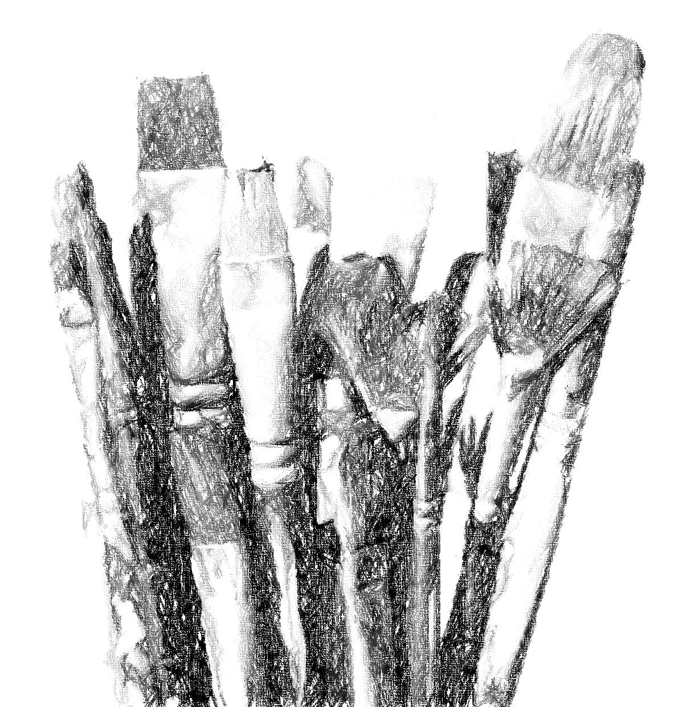

Name _______________________________

ART 30 COURSE OUTLINE 2018-19 SEMESTER 1

This year I am implementing a revised and reworked Art 30 course for the 2nd year. The new course will allow you to work even more independently than students at this level in the past; though I will still give you requirements you must adhere to, you will have a lot more freedom in choosing how to carry out each assignment.

I Assignments
You will be required to produce five major pieces throughout the semester. You may choose to work on them each separately, completing one before beginning another, or you may choose to work on two or more simultaneously. I will give you approximate amounts of time to spend on each as a guideline to ensure you get them all finished in time.

II Notebook
You will be given a notebook in class, as usual. Most of the art theory notes are review for you. The exception is the 3D notes, which include some reading and which you will do before you start assignment #4.

III Sketchbook(SB)
Please have your SB with you in class at all times, but also take it home in order to complete your sketchbook assignments.
REQUIREMENTS: 5-credit students – 20 drawings. Choose your own assignments from the list provided (it will also be posted in the classroom and on Weebly) OR find your own assignment ideas online OR come up with your own ideas. I will be looking for a wide variety of approaches, themes, subjects, and media. Please include with each drawing: the # of the assignment, your signature, and the date you completed the drawing.
I will be marking your sketchbook only twice, once at the end of each quarter. It is worth 30% of your term mark. I will not formally check your assignments but I will be looking in your sketchbooks informally on a regular basis.
You will also use your sketchbook for information, thumbnail sketches, and various studies in preparation for larger pieces.

Due before the end of Sept. You are required to look up two living Canadian artists, preferably who are very different from each other. Create a presentation including biographical information, examples of their work, some analytical response to the pieces including your own response to them, an explanation as to why you chose them, and anything else of interest. Form of presentation is up to you; poster, report, power point… Please use your own words (do not merely copy and paste your text).

IV Art History

Art 20 Curriculum: Not applicable this year.

Modern Art: 1750 to mid-20th Century
1. The Modern World: Neoclassicism
2. Romanticism
3. Realism
4. Impressionism
5. PreRaphaelite Brotherhood
-----------------------------------------
6. Post-Impressionism
7. Pablo Picasso
8. Expressionism, etc.
9. Dada and Surrealism
10. Pop, etc.

Art 30 Curriculum: Applicable this year.
Canadian Overview: 1600s-1800s
J.W. Morrice (video)
Tom Thomson and The Group of Seven
Emily Carr: Growing Pains and The Little Old Lady on the Edge of Nowhere
(video)
Discussion of Emily Carr with filmstrip.
David Milne (film and filmstrip)
A.J. Casson: The Only Critic is Time (film)
Jack Bush (film)
Paul-Emile Borduas (film)
Alex Colville: The Splendour of Order (video)
Riopelle (film)

V Tests One per quarter and a final exam in June.

VI Evaluation
All assignments, including major pieces and sketchbook work, will be marked according to the rubric posted in the classroom and inserted in the back of your notebook.

Quarters 3 and 4 Tests 10%
Sketchbook 30%
Studio 60%

Final Grade Quarters 3 + 4 85%
Exam 15%
100%

Sketchbook Assignment #1 Power Point Rubric
Name _______________________________ Artists _________________________

 | Powerful (4) | Proficient (3) | Adequate (2) | Limited (1)
Content | Completely covers all required parts of investigation. | Completely covers most required parts of investigation. | Covers most parts of investigation. | Investigation hardly covered at all. | X 4 =
Layout | Pleasing to the eye. Appropriate use of headings and sub-headings, so that each slide is clearly and consistently structured. | Appropriate use of headings and sub-headings. Slides are clearly structured and not cluttered. | Layout shows some structure; there is clutter; readability is hampered, and/or there are large empty spaces. | Layout is cluttered and confusing. Poor use of spacing, headings and sub-headings. Hard to read. | X 1 =
Text | Easy to read. Font size/style vary appropriately. Text is appropriate length. | Fonts are generally easy to read. Font size/style vary appropriately. Borders on too much text. | Text is somewhat difficult to read. Too many fonts, and too much text. | Text is difficult to read. Inappropriate font sizes, too many font styles, and/or font size too small. | X 1 =
Graphics | All graphics related to and enhance content. All graphics are appropriate size and good quality. | All graphics related to content. All graphics are appropriate size and good quality. | Some graphics are unrelated to content, too many graphics on one slide, and/or images are poor quality, too small, or too large. | Most of the graphics are unrelated to content and therefore distract from the text. Poor quality, too small or too large. | X 1 =
Writing Mechanics | No errors in grammar, capitalization, punctuation, or spelling. | 1 or 2 errors in grammar, capitalization, punctuation, or spelling. | Several (more than 3) errors in grammar, capitalization, punctuation, or spelling. | Many errors in grammar, capitalization, punctuation, or spelling. Difficult to read as a result. | X 1 =

Comments:

ART 10/20/30 COMPOSITION/ELEMENTS/PRINCIPLES in ART

I What is composition?
The organization and arrangement of the visual elements (ie. line, shape, value/tone, colour,
texture) in a work of art in a unified way. All 2D art can be analyzed by these standards,
whether representational or non-objective, or anything in between.

II Elements – ie. tools or ingredients of art

1. LINE- expressive of mood; leads eye through comp.; creates movement, creates structure, pattern, texture, shape, tone.

2. SHAPE – all objects can be reduced to simple shapes, whether geometric or organic. Shape can be distinguished by all other elements.

3. TEXTURE – visual or tactile (seen or felt); create with all other elements.

4. TONE/VALUE – lightness and darkness – helps create mood, focus, pattern, rhythm,
form (modeling).

5. COLOUR – mood, symbol, light, movement, creates form.

III “Preliminaries” or Foundational principles of 2D art

1. PICTURE PLANE – FLAT surface artist works on; may be treated anywhere from 2D (usually
decorative) to 3D (illusionistic, like a window), and anywhere in between.

Picture Plane is
2D, ie. unbroken. Picture Plane is 3D, ie. broken.

2. FRAME SHAPE – boundaries of picture plane; shd fit comp; rectangle most common.

3. POSITIVE AND NEGATIVE SHAPE – positive is what is first laid down by artist; negative is“leftover”;
can be clearly pos or neg; can flip-flop; can be ambiguous.
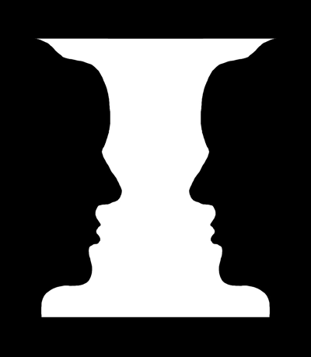
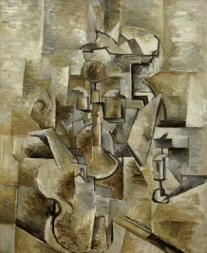
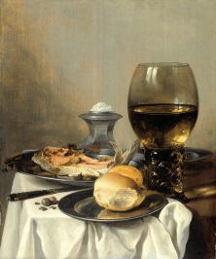

4. PERSPECTIVE – showing (illusion of) depth on flat surface by various methods.

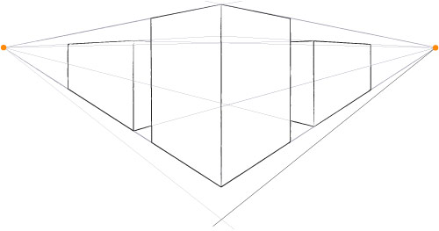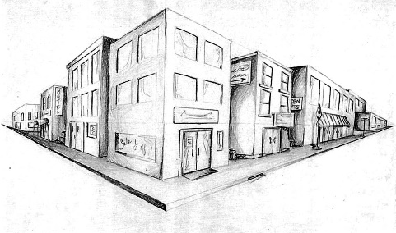

IV Principles – guidelines for using tools
- FOCAL POINT – starting pt./resting pt. from which all eye movement begins.
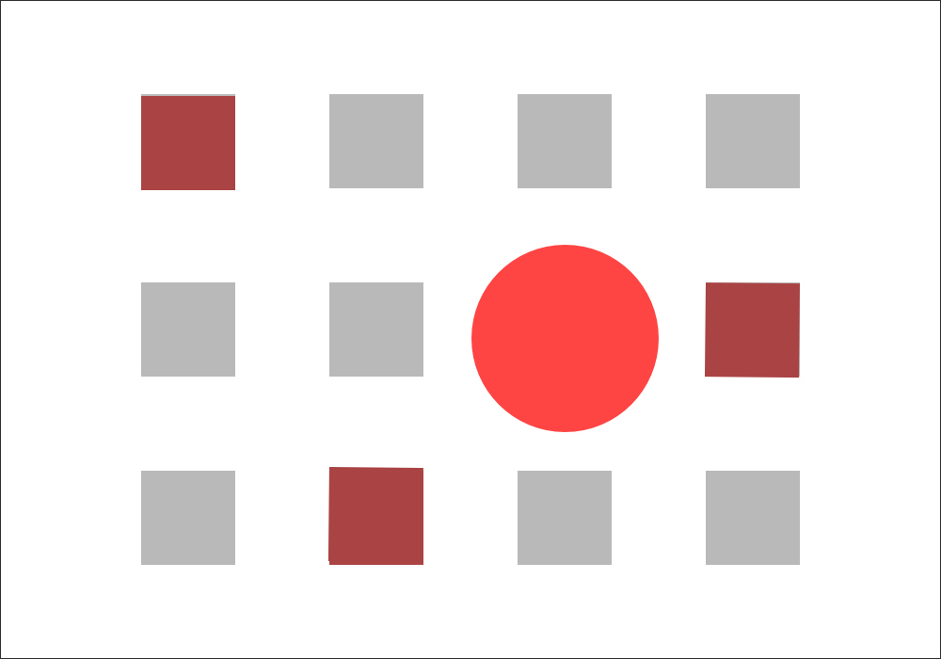

2. Movement – the visual movement directed by the artist to bind the parts “…should
assure that all areas of the picture plane are exploited, ie. that there
are no DEAD SPOTS…by directing shapes and lines toward each other…
so that the spectator is unconsciously swept along visual channels”.
(Art Fundamentals, p.34)
What hinders movement? 1) object(s) in middle of picture plane
2) repeating frame shape within plane
3) empty space at edges – if you can cut off edges without affecting the
comp., movement not working.

3. SAMENESS/REPETITION – repeating elements (whether shapes, colours, lines, etc.); not always
exact duplication, but similar. Rhythm through repeated elements helps create movement.
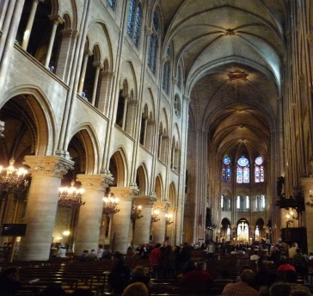
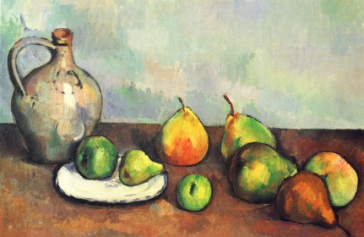

4. VARIETY – opposite of harmony; contrast, differences to add interest. Eg. varying heights of objects
(simple triangular comp, 3 objects, 3 heights, usually works well)
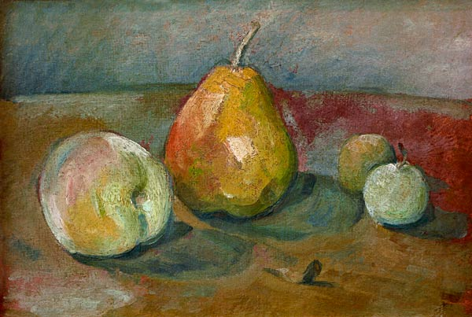

5. BALANCE – visual equality (in attention) on both sides.
a. symmetrical – same arrangement of elements on both sides.
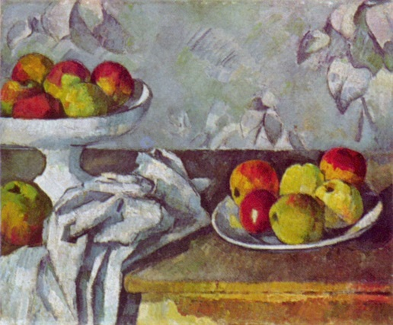
b. asymmetrical – different arrangement. More interesting. Hint: use odd number of objects.
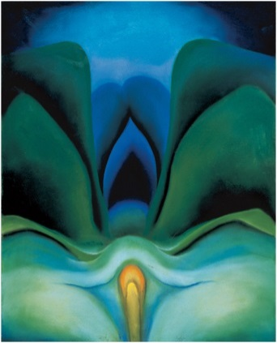
.

6. UNITY – total effect of all parts working together; “comfortable” compositions have unity.

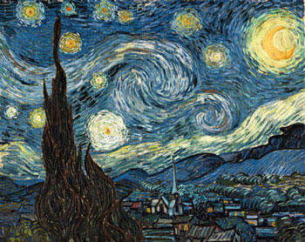

ART 20/30 DRAWING METHODS (See your sketchbook/journal for examples)

- GESTURE: A quick, spontaneous method focusing on the “inner energy” of the form rather than the edges. Keep drawing tool on surface until drawing complete.

- CONTOUR: Drawing only the edges/outlines of the subject; a slow, deliberate method; aim for a smooth, confident line as opposed to a broken “scrubbed” line.

- Blind Contour: Drawing subject looking ONLY at the subject, not at your paper.
- Modified Contour: Drawing subject looking MOSTLY at the subject, a bit at your paper.
*SIGHTING: A technique used to improve proportion; using your finger or pencil to measure sections of your subject in comparison to other sections.

- CONTOUR-GESTURE: A free, energetic drawing which touches the edges. Best not to remove drawing tool from surface until drawing complete.

- MODELLED/MASS: A drawing which is shaded (ie., using a variety of tones) to give a sense of solidity, mass, weight. Tonal changes are influenced by light and texture.

Some modeling methods and suggested media:
- Smudging – charcoal, conté
- “Shading” – pencil, conté, coloured pencil
- Hatching/Cross-hatching – pen and ink, pencil, marker, ballpoint pen
- Stippling – pen and ink, marker, ballpoint pen

PARTIAL DELINEATIONS (“Incomplete” drawings): Parts of images may be left undrawn, ie., only partially delineated, in such a way that the area left out is completed in the “mind’s-eye” of the viewer. A partially delineated drawing involves a strict economy of line; the lines/shapes that are drawn must be sensitive and accurate. These drawings should look fresh and spontaneous as opposed to over-worked and heavy.

ART 20, 30 PERSPECTIVE (Methods of showing depth on a 2D surface)

Principles of Perspective
- Objects up close are larger than objects of the same size farther away.

- Objects up close are lower on the paper; objects farther away are higher on the paper.

- Objects up close overlap objects that are behind them.

- Objects up close usually appear darker and more vivid than objects in the distance which are lighter and hazier. This is called ATMOSPHERIC PERSPECTIVE.

- Parallel lines converge (come together) at the horizon line. This is called LINEAR PERSPECTIVE. There are 3 methods used to create linear perspective.

- One-Point = one vanishing point (*NB. All corners of cube are vertical.)

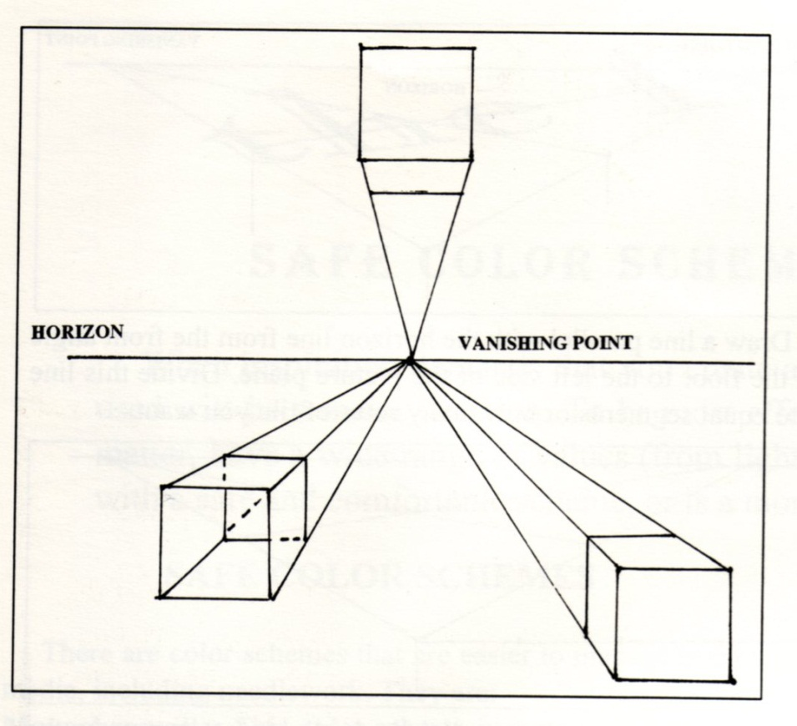

- Two-Point Perspective = two vanishing points (*NB. All corners are vertical and all sides converge at horizon line.
Exterior Interior
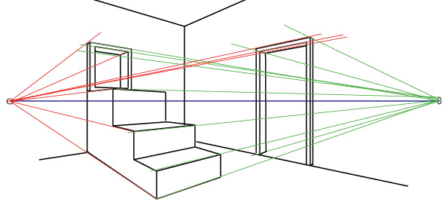
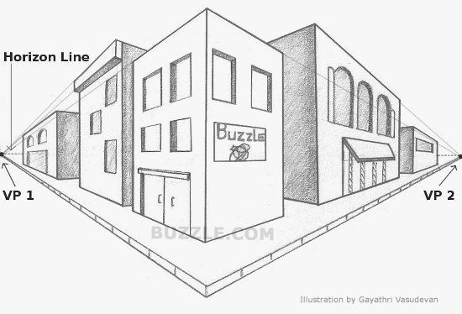

- Three-Point Perspective = three vanishing points (*NB. May be one or no vertical corners and all sides converge in three directions.)

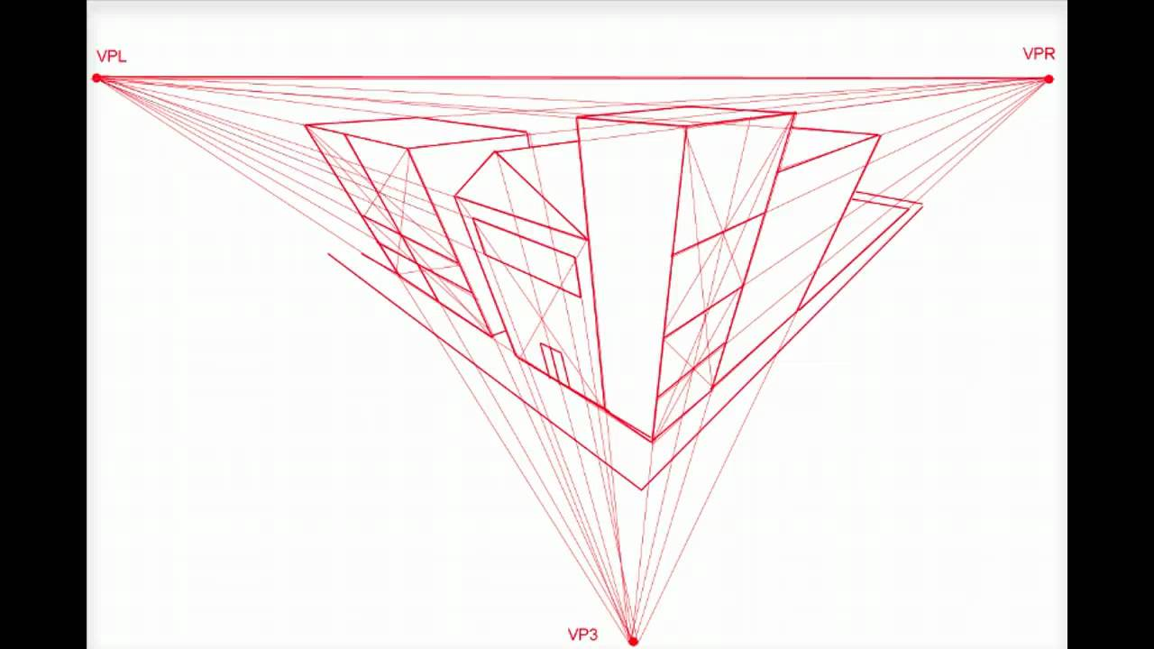

ART 10,20,30 PORTRAIT PROPORTIONS (The proportions of the human face)
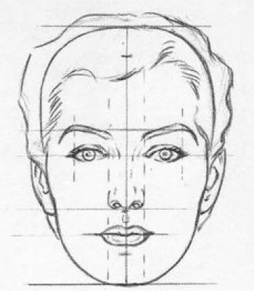

THINGS TO REMEMBER!!
- Midpoint of eyes is halfway between top of head and bottom of chin.
- Bottom of nose is halfway between midpoint of eyes and bottom of chin.
- Width of nose = space between eyes.
- Ears generally lie between midpoint of eyes and bottom of nose.
- Neck is drawn from jawline gradually widening toward shoulders (not in drawing).

ART 10,20,30 ABSTRACTION METHODS (See Presentation on Weebly for examples)
What is Abstraction?
Abstraction comes from the verb “to abstract”, which means “to take away from”. True abstract art, then, always begins with something from real life which the artist changes in some way. There are four main ways artists abstract things from real life.

- SIMPLIFICATION: Taking away details, flattening 3D objects into organic or geometric shapes; flattening colours

- DISTORTION: Making specific parts bigger, longer, smaller; twisting or “melting”; drastically changing texture or colour.

- EXAGGERATION: Magnifying or multiplying object; making object significantly smaller.

- REARRANGEMENT: Taking object apart and reassembling it in a new way; showing more than one point of view at a time.

What is Nonobjective Art?
Art which has as its source something NOT from real life is called “Nonobjective”, literally “no object”. Nonobjective art focuses instead on the elements inherent in art, ie. line, shape, colour, tone, texture, space.

ART 30 SCULPTURE/ART IN THE THIRD DIMENSION (From Art Fundamentals)

I Basic 3D Concepts (p.148)

1. Depth –

2. Form –

3. Shape –

4. Mass –

5. Volume –

II Materials and Techniques (p.152)

- ADDITION: To build up, construct, assemble.
Possible materials: wood, found objects (objet trouvé), metal, etc., put together with nails or glue, or welded together.

- SUBTRACTION: To cut away, carve.
Possible materials: marble, wood, soap, etc.

- MANIPULATION/MODELLING: To shape a pliable material (ie. bend or squish in hands).
Possible materials: clay, wire, playdough, etc.

- SUBSTITUTION/CASTING: A technique in which liquid materials are shaped by having been poured into a mold.
Possible materials: metals, such as gold and bronze, plaster, wax.

III The elements of 3D Form (Elements of Design) (p.154ff)
1. Shape –

2. Value –

3. Space –

4. Texture –

5. Line –

6. Colour –

- Time –

ART 30 COLOUR THEORY REVIEW

I Colour Classifications

- Primary colours are red, yellow, and blue. These colours cannot be made using other colours, but can be mixed together to make all other colours.
- Secondary colours are orange, violet (purple), and green. These are made by mixing pairs of primaries (see colour wheel below).
- Colours may be arranged on a wheel.
P=Primary
S=Secondary
T=Tertiary

These are not the only possible combinations as there are an infinite number of colours between each colour shown on the wheel, and an infinite number of colour combinations across the wheel.

- Colour “Temperature” – Red, orange, and yellow are considered WARM, while blue, green, and violet are considered COOL. In general, every colour composition should have both warm and cool colours, though one may predominate. Keep in mind that these temperature classifications are general; ie., a colour’s temperature will always be affected by the colour(s) beside it, so that red may sometimes appear cool and green may sometimes appear warm.
Warm colours tend to appear closer, larger, and lighter in weight; cool colours tend to appear farther away, smaller, and heavier.

II Colour Schemes (groupings)
Colour schemes are based on relationships of colours to one another, similarities and differences. Remember, as noted above, a colour is always affected by the one(s) placed next to it.

- Complementary colour scheme – 2 colours opposite on colour wheel; highest possible contrast. Complements bring out the best in each other; ie., red beside green looks as red as possible and vice versa. Illustrate on above wheel.
- Split-complementary – 3 colours: one colour + the 2 colours on each side of its complement. Eg. red + blue/green and Yellow/green. High contrast.
- Analogous colour scheme – 3 or 4 colours beside each on colour wheel; lower contrast. Illustrate on above wheel.
- Monochromatic colour scheme – variations of one colour (hue).
- Triadic – 3 colours equidistant from each other on the wheel, ie., forming an equilateral triangle, eg. red, yellow, and blue; fairly high contrast.

*NB Keep in mind this Rule of Contrast – The farther away from each other colours are on the wheel, the higher the contrast; the closer colours are together on the wheel, the lower the contrast.

III Colour Properties (ie., ways we describe or identify colours)

- Hue – colour name, eg. blue, red, orange, etc. Hue is changed by adding another colour.

- Value/tone – lightness and darkness of a colour; lighten by adding water (watercolour) or by adding white (acrylics, oils, tempera)

- Intensity – brightness and dullness. Dull a colour by adding its complement; eg., dull yellow by adding purple. A colour cannot be made brighter than it is.

*NB Make gray by mixing approximately equal amounts of complements – this will make a more natural gray and also allows for a greater of variety of grays than merely mixing black and white.

IV Compositional Principles

In order to achieve colour harmony/sameness, repeat colours.

In order to achieve colour balance, use similar colours on both sides of picture.

In order to achieve colour unity, limit hues to from 3 to 5 (not including black, white, or gray).

ART 30 PAINTING NOTES

I Watercolours

1. Characteristics
~ can be bought in blocks or tubes; water soluble.
~ small amount of pigment mixed with a lot of water.
~ transparent medium; layers of washes; mistakes hard to cover.
~ cheaper than oils and acrylics; easy to transport and quick-drying.

2. Materials
~ usually done on heavy paper; best paper is handmade with a high “rag” per-
centage (as opposed to wood pulp); “cold-pressed” paper is highly textured;
hot-pressed is smoother; heavy paper keeps the paint longer on the surface,
allowing the colour to be moved around easily.
~ brushes are soft and flexible; best brushes are made of “sable” and are very
expensive; should never be left bristles down in water.

3. Painting Process
~ underdrawing lightly in pencil.
~ large areas washed in first, then work in detail.
~ work light to dark, since light colours will not cover dark ones.
~ white is rarely used; white of paper used to show lightest areas; white used
on coloured papers.

II Oils

1. Characteristics
~ oils bind the pigment, therefore drying time is lengthy.
~ quite expensive depending on the colour.
~ soluble in turpentines, paint thinners, etc.
~ thinned with above chemicals, best with linseed oil.

2. Materials
~ non-absorbent surfaces, eg. stretched canvas, canvas board, wood,
masonite; surfaces primed first with gesso.
~ stiff brushes
~ palette paper and surface
~ paint thinner (varsol, turpentine)

3. Painting Process
~ cover white gessoed surface with warm “ground” (umber, sienna)
~ sketch composition with same colour as ground with brush, or draw with
chalk.
~ block in dark areas with ground colour.
~ recommended colours on palettes: light and dark of each primary; white;
umber (raw and/or burnt); sienna (raw and/or burnt); optional colours
are green (variety) and violet; other colours depending on subject matter.
~ light colours can be painted over dark, but don’t do this too much because
colours can end up looking drab.
~ if painting a landscape, paint sky using a mix of white + cerulean blue + a bit
of cadmium red and cadmium yellow (medium) – the red and yellow warm up
the cold blue.
~ allow a long time to dry; when dry, paint is permanent.

III Acrylics

1. Characteristics
~ a synthetic (manmade) paint: acrylic resin binds pigments.
~ oil consistency, but can be used as oil or watercolours.
~ water soluble; thinned with water for watercolour use; thinned, and drying
time extended, with acrylic medium.
~ almost as expensive as oils.
~ more resistant to heat, light, and climate than oils (not yet time-tested
over centuries).

2. Materials and Painting Process
~ same as oils if used as such, though can be done on heavy paper surface
(some bending/ wrinkling of paper occurs); dries very quickly, and
faster than oils even if medium used.
~ same as watercolours, if used as such.

