MARTIN FROBISHER
British explorer Martin Frobisher left for the Arctic in 1576 in search of the Northwest Passage (ie. a sea passage to Asia, north of North America). His fleet consisted of three small ships containing trade goods for Asia: linen, silk ribbons, laces, cloths of gold, velvet, children’s straw hats, dog collars, mirrors, silk purses, combs, gold and silver rings, and fake pearls, diamonds, rubies and emeralds.
Frobisher reached Labrador and Baffin Island, and sailed through the bay that is named after him (he was the first European explorer to get this far). He returned to Britain, with all the goods he’d taken with him, as well as a piece of gold, in order to convince his British sponsors that the land was rich in gold. Unfortunately, the gold was declared by an expert in England to be iron pyrite, or “fool’s gold”; even so Frobisher was able to find another expert who disagreed, and he returned to the Arctic where he mined a thousand tonnes of iron pyrite which were completely worthless. (Our Canada, www.pbs.org/empireofthe bay)

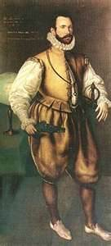

MARTIN FROBISHER
- What year did Frobisher go on his first journey?
- What was he looking for?
- What are three items he took on his ship with him?
- Did he find what he was looking for?
- What did he find?
- What did he accomplish?

HENRY HUDSON
In 1610, Henry Hudson set out from Britain in an attempt to find the Northwest Passage on the ship Discovery. Passing through a strait he headed into a large body of water, which he mistakenly expected would take him to China. He continued south until he realized he was in a large bay, which is now named after him (Hudson Bay).
Hudson’s ship got trapped in ice in 1611, and his crew spent the winter battling scurvy and starvation. In the spring, Hudson wanted to explore further, but his crew rebelled. They abandoned Hudson, his son and seven others in a small boat. The oral history of the Cree records that Hudson died, and that members of the Woodland
Cree adopted his son. (Our Canada)
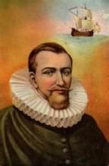

HENRY HUDSON
- What year did Hudson go on his expedition in the Discovery?
- What was he looking for?
- What happened in the winter of 1611?
- What eventually happened to Hudson?
- What did Henry Hudson accomplish?

GIOVANNI CAB OTO
(John Cabot)
Giovanni Caboto was an Italian sailor who lived in Britain. In 1497 he set sail in a tiny ship Matthew to search for a sea route to China. It is not known for certain where he landed, although it was likely Newfoundland or Labrador. He claimed the land for Britain, and returned home with reports of seas so full of cod you could scoop fish up by the basketful. As a result of these reports, fishers began sailing to the banks of Newfoundland every summer for huge catches of fish, which they then took back to England to sell. Britain lost interest in exploration to North America for some time after this, since the new land did not seem to have any valuable resources to offer. (Our Canada, The Blue and the White)
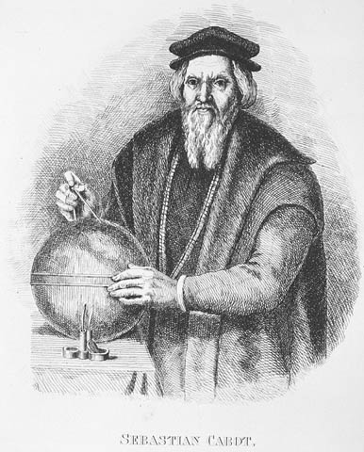

GIOVANNI CABOTO
- What nationality was Caboto?
- What country sponsored his expedition to North America?
- What was he looking for?
- What did he find instead of gold and jewels?
- What did Caboto accomplish?

JACQUES CARTIER
Jacques Cartier was born in St. Malo, France. He made three voyages to what is now Canada.
In March 1534, Cartier sailed between northern Newfoundland and Labrador, through the gulf of St. Lawrence, to the Gaspé Peninsula. There he raised a 30’ wooden cross, claiming the land for France. He met Donnacona, a Haudenosaunee chief from the village of Stadacona near present-day Quebec. When Cartier returned to France, he took two of Donnacona’s sons with him to act as guides when he came back.
In May 1535, Cartier sailed back to Canada the same way, but sailed down the St. Lawrence River as far as a town called Hochelaga, near present-day Montreal. He and his men spent a miserable winter there, losing many men to scurvy. When he left for France the next spring, he kidnapped Donnacona and a few others and took them to France where most of them eventually died.
In May 1541, Cartier returned for the third time, and spent another difficult winter near Stadacona waiting for his partner, Roberval, who only arrived after Cartier left. Both Cartier and Roberval failed to found a colony in Canada.
Jacques Cartier is credited with naming the country; the Haudenosaunee spoke to him of “Kanata”, referring to their village, or “group of huts”, and Cartier assumed they were referring to the entire country. Cartier was the first European to sail into the St. Lawrence River, and later to discover it was not, in fact, a big bay, but rather the mouth of a large river (and he was convinced he’d found the inland route to Asia).
Cartier’s journals indicate he traded with the Mi’kmaq on his first trip. The response of the Mi’kmaq indicated they were already familiar with Europeans and had traded before; likely they had been trading many years already with European fishers coming to fish off the east coast.
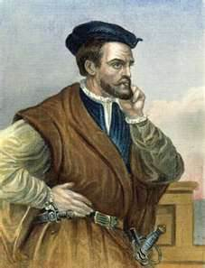

JACQUES CARTIER
- What years did Cartier take his three voyages to what isn ow Canada?
- On his first trip, what did he do on the Gaspe Peninsula in order to claim the land for France? How do you think the First Nations reactied to this?
- What First Nations chief did he meet at this time?
- What happened to Cartier’s group when they spent the winter at the village of Hochelaga?
- Cartier twice took natives back to France with him. Why dod you think he did this, besides needing them as guides when he returned (which si why he took Donnacona’s sons the first time)?
- What are two of Cartier’s accomplishments?
- READ excerpts of Cartier’s journals on pp.52-55 in your blue text. In the excerpts from June 24 and July 6, 1534, what tells us that the natives were used to trading with Europeans already (ie. How does the way they behaved show this?) Why do the Frenchmen shoot their guns at one point and why are the natives so afraid?

SAMUEL DE CHAMPLAIN
Champlain was born in France, and became a skilled navigator and cartographer (mapmaker). He made his first voyage to Canada in 1603 when he sailed down the St. Lawrence River looking for Hochelaga, the village discovered by Cartier. The village had disappeared completely by then. Aboriginals he met told him, however, that beyond the river lay a large lake, then a waterfall, then another huge lake no one had seen the other end of, a lake they claimed was very salty. This convinced Champlain he had found the route to China!
King Henry IV, the French king, was interested in starting a colony in North America, and he gave Champlain and his partner, Du Monts, a fur trade monopoly (ie. total control over all trade with First Nations) as long as they founded a colony, explored the land, and evangelized First Nations.
Between 1604 and 1605, Champlain and Du Monts set up a colony in present-day New Brunswick first, which failed miserably when half the men died of scurvy and cold over the first winter; they then moved the colony across the Bay of Fundy to present-day Nova Scotia, and called it Port Royal. With the help of the Mi’kmaq the settlers found adequate food as well as a cure for scurvy. Port Royal grew, but in 1607, realizing the French were too far away from the source of furs, King Henry IV recalled all the inhabitants back to France. (Port Royal was revived a short time later, nonetheless.)
Champlain left France again in 1608, and founded a new colony near the former site of Stadacona. The Aboriginals called the site kebec, meaning “where the river narrows”, from which we get the name Quebec. There Champlain built a fur trade fort, and Quebec became the first permanent settlement in Canada and the oldest continuous North American settlement north of Florida (what anniversary did Quebec City celebrate in 2008?). (Canada:The Making of a Nation)
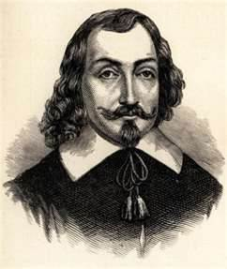

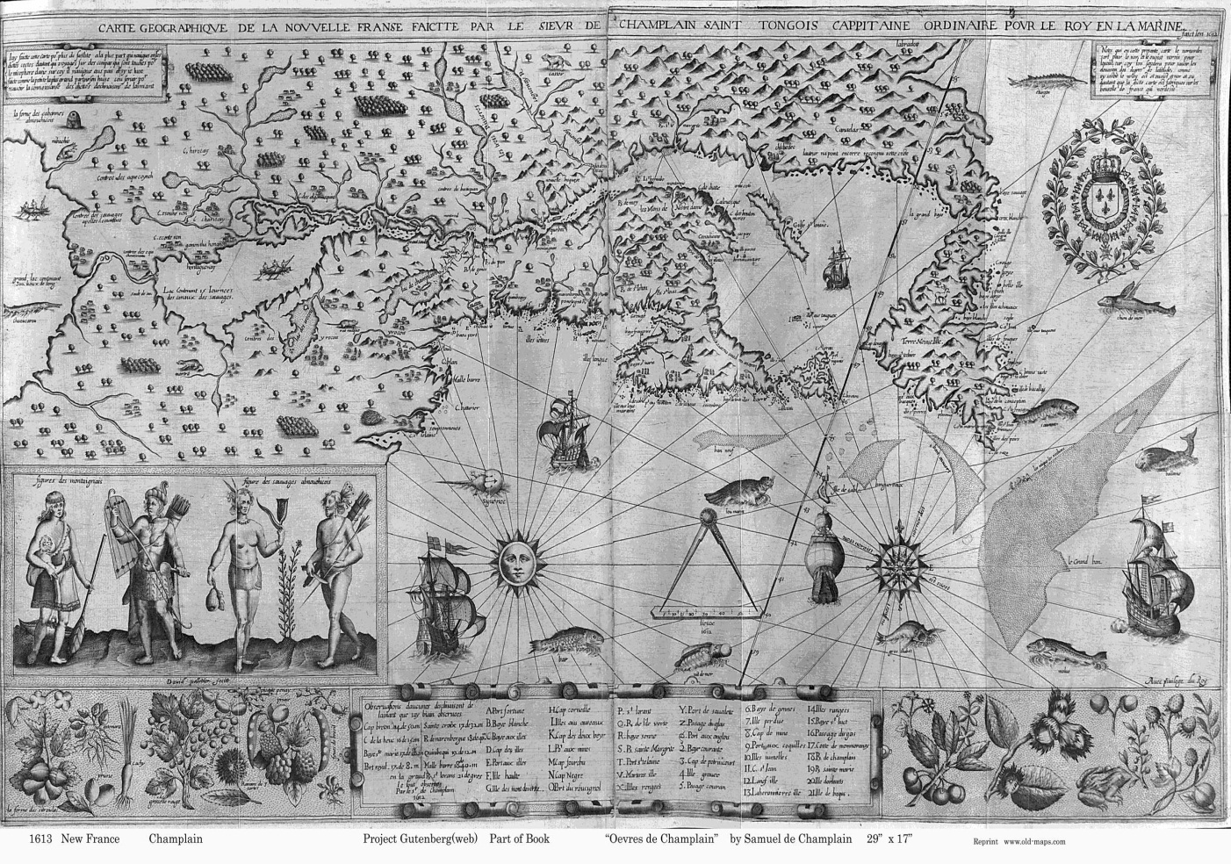

Champlain’s map of North America
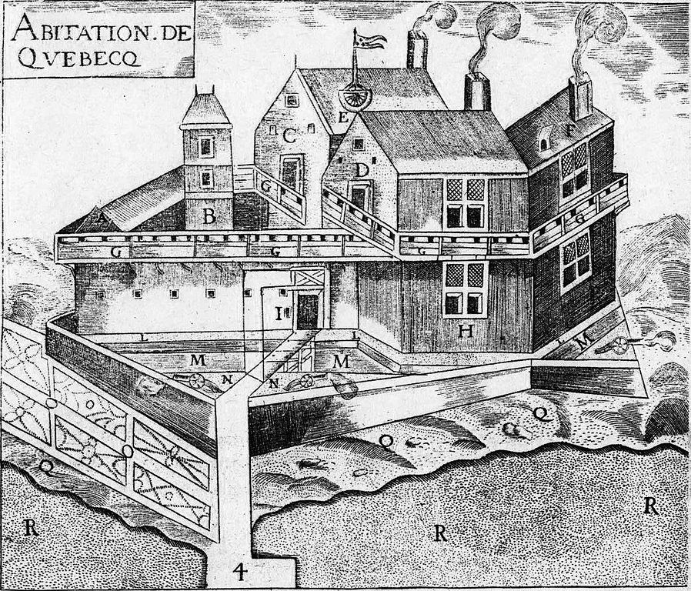
Champlain’s drawing of the original settlement at Quebec, called “Habitation”.
Champlain
- What village was Champlain looking for during his first voyage, in 1603?
- What is a fur trade monopoly?
- Besides engaging in trade, what three other goals did Champlain and du Monts pursue in North America?
- What year did Champlain and du Monts set up the colony at Port Royal?
- What happened to the settlement at Port Royal?
- What does the word “Quebec” mean?
- What year was Quebec established?

RENÉ-ROBERT CAVELIER
DE LA SALLE
La Salle was sent from France to Canada by King Louis XIV to explore and establish fur rade routes along the Great Lakes and Mississipi River. From 1669 to 1673 he made several trips along the Great Lakes (all except Lake Superior) and possibly partway down the Mississippi. After a trip back to france for a year in 1677-78, in 1681 he and his men left on an expedition from Montreal to the Mississipppi River, which they followed south, eventually arriving at the Gulf of mexico in 1682. All the land along the river they claimed for France.
La Salle was a colourful character, not above “stretching the truth” when he thought it was necessary. For example, he claimed the ability to speak Iroquois, but when they entered haudenosaunee land, it became evident he had not such ability. He also lied to King Louis XIV about the location of the Mississippi River.
Later in the 1680s La Salle and his men faced great difficulties as they attempted to start a colony in what is now Texas (they landed at this spot by mistake, intending to land at the mouth of the Mississippi). After illness, struggles with the local Indians, and frustrated attempts to make their way back to the Mississippi River, La Salle was shot by his own men, a group of mutineers, in Texas in 1688, leaving his body for animals to eat.
(Our Canada, www.enchantedlearning.com/explorers/page/l/lasalle)
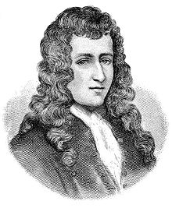

RENÉ-ROBERT CAVELIER
DE LA SALLE
- What year did La Salle make his first expedition?
- What did King Louis XIV, the king of France at the time, want La Salle to do in North america?
- How far south did La Salle and his men finally get?
- Was La Salle successful in his attempt to start a French colony in what is now the southern States?
- What eventually happened to La Salle?

