Map of French and British Colonies in the 1700s
French – gray
British – red
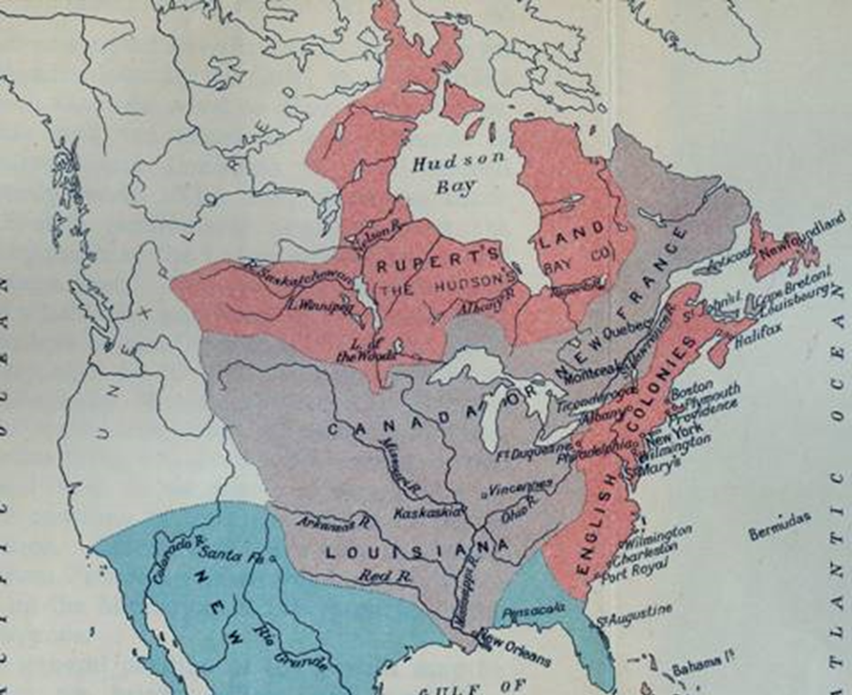
(Spanish – blue)

