SOCIAL STUDIES 7 UNIT 4A NOTES Name _______________________
Upper and Lower Canada: 1815-1838

Part One IMMIGRATION (PPT. and pp. 201-213 Blue Text)
Between 1815 and 1850, thousands of immigrants from Great Britain arrived in the Canadas, from England, Scotland, Ireland, and Wales.

Why did so many British people immigrate?
Most immigrated to Upper and Lower Canada or the Maritimes because of POVERTY
or, at least for economic reasons!
What caused such poverty in Britain?
- The Industrial Revolution: human labour was replaced with machine labour, therefore people lost their jobs.
- The end of the Napoleonic Wars brought economic depression and unemployment.
- A POTATO famine in Ireland
And also…
- Britain wanted lots of British people in the colonies in order to increase the colonies’ loyalty to Britain!
- It was a great way to start over and create a new life.
However, the trip to Canada was not a pleasure cruise…
People endured
BAD FOOD AND WATER
POOR SANITATION
VERY LITTLE SPACE
DISEASE
And therefore, many did not survive the voyage.
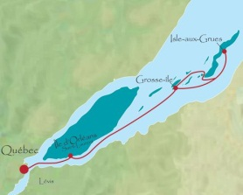
In fact, the vessels were nicknamed COFFIN ships.
Grosse Île was the quarantine island near Quebec City where all immigrant ships stopped, in order to check all immigrants for sickness.
Many people died of illness on Grosse Île, and in spite of efforts to
prevent it, many epidemics still occurred in the cities
of Upper and Lower Canada.
Part Two Politics in Upper and Lower Canada

Was the colonial government in “the Canadas” a democracy?
Sort of, but not really…
Although there was an elected assembly, as in all British-run colonies, very few people could vote. You had to be
Male
Over 21
A property owner
(or a widow who owned property)

Remember British colonial government?
Britain (monarch and parliament)
Governor (appointed by Britain)
Councils (appointed by governor, advised governor)
Elected Assembly (elected by voters, advised councils)
Voters (elected the assembly only)

Was everyone in Upper and Lower Canada happy with their government?
NO!
In Lower Canada…
The Governor’s council was made up of English Protestant merchants.
(nicknamed the “Chateau Clique”)
The Assembly was made up of mostly French Catholics.
Uh oh… French Catholics did not want to be ruled by a small group of English Protestants!
Therefore, a group calling themselves the Parti Patriote, began to fight for a more democratic form of government from 1820 on.

In Upper Canada
The Governor’s council was made up of wealthy English Canadians.
(Nicknamed “The Family Compact” Can you guess why?)
These men stood for loyalty to Britain and the authority of the Church of England, and formed the beginnings of the Conservative Party, or “Tories”.
Many people, including mostly settlers from the United States who were not loyal to Britain, objected to the Family Compact having all the power, and wanted a more democratic form of government.
They established the REFORM PARTY (which formed the beginnings of what eventually became the Liberal Party).

The result of all this discontent in Upper and Lower Canada was…
VIOLENT REBELLION

REBELLIONS OF 1837-38 IN LOWER AND UPPER CANADA
(pp.212-221 Blue Text)
I Lower Canada (Present-day Quebec)
- Lower Canada in 1800s made up of:

- The governing “council”:
The Assembly:

- From 1820s on, there were parties demanding a more democratic gov’t, mostly made up of Canadiens:

- Adding to the discontent with gov’t., British immigrants travelling to or through Quebec brought a cholera epidemic, killing almost 5,000 people. Lower Canada also suffered four years of crop failures, so that in the winter of 1837 many faced starvation.

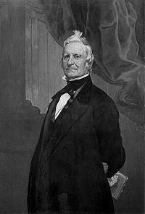
- Louis-Joseph Papineau and the Rebellion of Lower Canada (1837)
- What did Papineau want?

- What did the Assembly do in 1834, and how did the British
gov’t respond?

- Papineau encouraged the French to do what in response?

- The Patriotes wanted a new country; what did they do to
this end?

The Rebellion began when some Patriotes ambushed several Br. Soldiers and rescued two Patriote prisoners. On Nov. 23, 1837, Patriotes led by Dr. Wolfred Nelson defeated a British force at the village of St. Denis. In Dec. 1837, 600 Patriotes were hiding inside a church a St. Eustache. A British army of 2,000 soldiers set fire to the church, killing many and causing many to flee. This marked the end of the rebellion, and Papineau fled to the U.S., then to Paris.

II Upper Canada (Present-day Ontario)
- Who controlled the gov’t in Upper Canada?

- The Family Compact believed
- in the superiority of everything British, especially its political institutions, the Church of England, and the British Empire.
- That leaders should be men of high character, wealthy, knowledgeable, intelligent, and loyal.
- That
- That

- In 1836, the governor, through intimidation and bribery, made sure the party he favoured (ie. not the Reform party) won the majority of seats in the Assembly.
- Like in Lower Canada, in 1837 there were widespread crop failures.

- William Lyon Mackenzie and the Rebellion of Upper Canada (1837)
- Mackenzie was a hot-tempered, outspoken advocate of reform in his newspaper, the Colonial Advocate. He was elected to the Assembly, starting in 1828, four times.
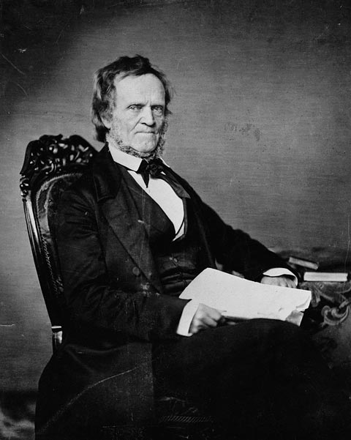
- Mackenzie and others formed the Reform Party and tried to make Upper Canada more democratic. They opposed the Family Compact because they
i.
ii.
iii.
iv.

The Rebellion was planned in December 1837, because the Rebels knew
British troops were fighting the rebellion in Lower Canada and would
therefore not be available to fight in Upper Canada. Like in Lower
Canada, people in Upper Canada were suffering food shortages from
poor crops, and hungry people become angry people! Mackenzie gathered men about him and attempted to overthrow the gov’t in York (Toronto). They met in early December at Montgomery’s Tavern, north of York, planning to march into the city and take over; but the rebellion was poorly planned, poorly organized, and the men poorly equipped, and gov’t forces and volunteers far more numerous. The rebellion was easily put down with only a few casualties and ended in 1838 after several raids were made into Canada from the U.S. where Mackenzie had fled.

As a result, the radical reformers in both Upper and Lower Canada lost public support and more moderate reformers, such as Robert Baldwin and Louis-Hipployte LaFontaine, took the lead in the fight to reform government.

Do you think violence was the best way to try to change the government?

