Unit Five The Opening of the West: Louis Riel and Métis Rebellions, 1869-1880
Name _________________________

I CAN explain the role, contributions, and influence of the Red River Métis on the Development of western Canada.

Critical Challenge: How would rate Louis Riel as a leader? Would you have followed him, as a Métis, as a First Nations member, and/or as a white settler?

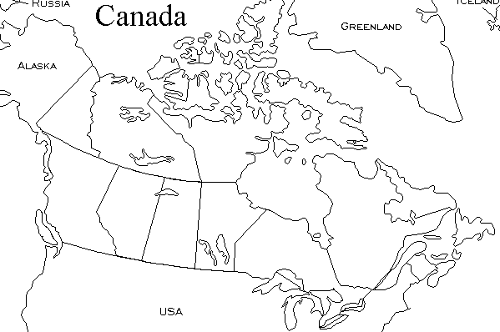

Characteristics of a Good Leader

The Red River Rebellion and the Creation of Manitoba (1869-70)
Red Text: pp.192-202 Blue Text: pp.273-291
Where did the Rebellion take place?
Causes of Rebellion
Riel’s Actions
Canadian government’s response

What happened to Riel after this rebellion?

The North West Resistance (1884-85)
Red Text: pp.212-217, 220-224 Blue Text: pp.294-301
Where did the Rebellion take place?
Causes of Rebellion
Riel’s Actions
Canadian government’s response

What happened to Riel after this rebellion?

Additional Questions

- In both rebellions, who had more control, the Metis or the Canadian government?

- What did the creation of the NWMP have to do with gov’t control in the west?

- a) What is assimilation?

b) Did the Canadian gov’t want to assimilate the Metis?

c) Did the Metis want to be assimilated?

- How was making Manitoba a province the gov’t’s attempt to make everyone living there happy (compromise)?

How would I rate Louis Riel as a Leader?

- __________________________ 1 2 3 4 5

- __________________________ 1 2 3 4 5

- __________________________ 1 2 3 4 5

- __________________________ 1 2 3 4 5

- __________________________ 1 2 3 4 5

- __________________________ 1 2 3 4 5

- __________________________ 1 2 3 4 5

- __________________________ 1 2 3 4 5

Based on the above evaluation, I believe Louis Riel was a _______________________ leader, and as a __________________________________ I would/would not (circle your answer) have followed him, because ______________________________________________________________________
_____________________________________________________________________________

