SOCIAL STUDIES 7 UNIT ONE PART B European Explorers Arrive Pp.39-42 Blue Text
Name _________________

1. What were Europeans Seeking?
- Europe had traded with Asian countries for exotic goods (eg. silk, spices, ivory) since the Middle Ages.
- Trade routes were overland (Silk Road).
- In 1300s, routes became more dangerous because no longer protected by Mongol Empire (lost power)
- Prices of goods increased.
- Therefore some Europeans wanted to find a better way to get these goods.
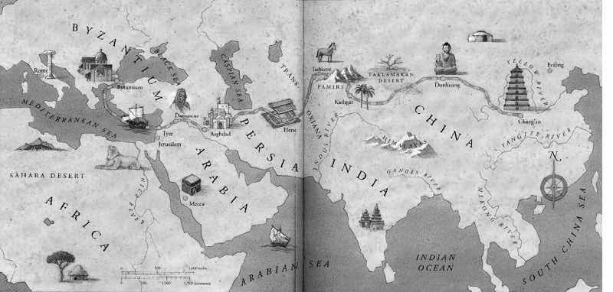

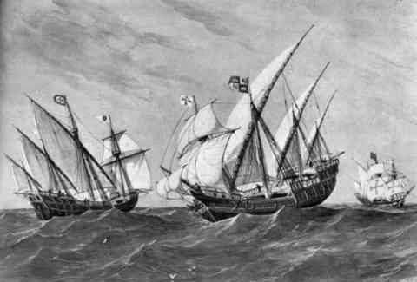
2. How did Technology enable exploration?
- The only option was to look for a sea route.
- But sea travel very risky (ship wrecks, getting lost).
- In 1400s, better ships designed – faster and easier to handle.
- Rediscovery of compass and astrolabe (direction and location)

3. Why did Europeans arrive in what became Canada?
- Portuguese were first to find sea route in 1488 sailing around south of Africa
- They protected this route so no other country could use it.
- Columbus (Italian) was first to find western sea route in 1492; found Caribbean instead of Asia!
- Giovanni Caboto (also Italian, but sailing for England) first to land on NE coast of Canada (NFLD) since Vikings.
- Caboto’s reports of teeming fish brought European fishers to Canada every summer.
- No permanent settlement occurred in Canada at this time.
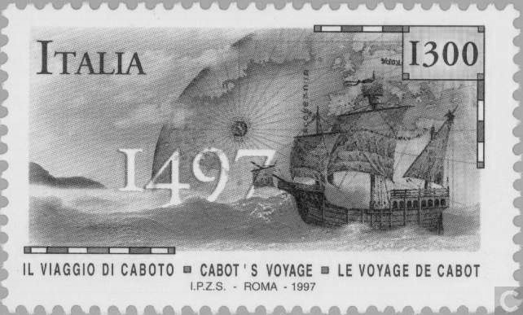

*Who was the first explorer to sail around the world and when did he do it? (A Spaniard named Magellen, 1519-21)

